**Software Architecture Document**

**Internet provider “Wind”**

**Solution Information**

|  |  |
| --- | --- |
|  | Information |
| Solution Name | Internet provider “Wind” |
| Solution Acronym | WB |
| Document Owner | Bed Anatolii |
| Version/Release Number | 1.0 |

**SAD Revision History**

|  |  |  |  |
| --- | --- | --- | --- |
| **Date** | **Version** | **Description** | **Author** |
| 02.04.2014 | 1.0 |  | Bed Anatolii |
| 17.05.2014 | 1.1 |  | Bed Anatolii |

Definitions, Acronyms and Abbreviations

**UML:** Unified Modeling Language

**SI:** Service Instance

**SL**:Service Location

**RI:** Resource Inventory

SO: Service Order

Table of Contents

Purpose 5

1. Solution Overview 5

2. Architectural Goals and Constraints 6

2.1 Architectural Assumptions and out of scope 6

2.2 Technology 6

3. Application Architecture 8

3.1 Logical View 8

3.2 User Interface 9

3.3 Supported Business Processes 15

3.3.1 Creating Employee Account 16

3.3.2. Creating Customer Accounts 19

3.3.3. Blocking Accounts 23

3.3.4. Changing Customer Password 24

3.3.5. Review Service Instance 28

3.3.6. Review Service Order 29

3.3.7. Creating Service Order 31

3.3.8. Creating Customer Account by Customer Support Engineer 35

3.3.9. Service Order Processing 39

3.3.10. Creating New Router in System 42

3.3.11. Creating New Circuit in System 44

3.3.12. Removing the Circuit in System 48

3.3.13. Bill Sending 51

3.3.14. Creating Service Instance 55

3.3.15. Modifying Parameters for Service Instance 56

3.3.16. Disconnect for Existing Service Instance 60

3.3.17. E-mail Notification 64

3.3.18. Creating RI Reports 65

3.3.19. Creating SI Reports 67

3.3.20. Creating CIA Reports 69

3.3.21. Exporting Reports 71

3.3.22. Creating Reports 73

3.3.23. Review Service Instance by Customer 75

3.3.24. User Logs In 76

3.3.25. Cancel Service Order 79

3.4 Sequences 80

3.5 Data managment 95

3.6. Security Architecture 96

4. Reporting 98

5 Resource Inventory 99

6 Test Strategy 100

7 Product Testing 101

# Purpose

The purpose of this document is to define the detailed Solution Architecture for “WindBoreas”. This system provide ability full-cycle service provisioning with the usage of self-service portal. The document ensures that the Solution Architecture is in compliance with enterprise application architecture principles, best practices, and conceptual target application architectures.

# Solution Overview

The system is solution for internet providers. The system allows you to arrange a convenient interface between you and your customers, have a pleasant and intuitive interface, which allows ordinary Internet users to take advantage of your services. You can provide information on the tariff plan, quickly implement an internet connection to your customers, establish a feedback from them, organize technical support. This will allow your customers receive the highest level of service. You can receive automatically generated reports on the state of the system . This is a good tool for the successful organization and business automation. In the system can exist 5 roles: Administrator, Customer Support Engineer, Provisioning Engineer, Installation Engineer, Customer User. Basic operation items are Service Instance, Service Order.

# Architectural Goals and Constraints

This section describes the software requirements and objectives that have some significant impact on the architecture.

## 2.1 Architectural Assumptions and out of scope

One user have only one role. System uses English language for text and graphical screens.

## 2.2 Technology

|  |  |  |
| --- | --- | --- |
| Name | Solution | Description |
| Server | GlassFish 4.0 | GlassFish Server is the world's first implementation of the Java Platform, Enterprise Edition (Java EE).  Built using the GlassFish Server Open Source Edition, GlassFish Server delivers a flexible, lightweight, and production-ready Java EE 6 application server. |
| Databases | OracleXE 10g | Oracle Database 10g Express Edition (Oracle Database XE) is an entry-level, small-footprint database.  It's free to develop, deploy, and distribute; fast to download; and simple to administer. |
| Technologies | Servlet | Servlets used to extend the applications hosted by web servers, so they can be thought of as Java applets that run on servers instead of in web browsers. |
| JavaMail API + Apache James | The JavaMail API provides a platform-independent and protocol-independent framework to build mail and messaging applications.  Apache James is an open source SMTP and POP3 mail transfer agent and NNTP news server written entirely in Java. |
| JAAS | Java Authentication and Authorization Service, or JAAS, is the Java implementation of the standard Pluggable Authentication Module (PAM) information security framework. The main goal of JAAS is to separate the concerns of user authentication so that they may be managed independently. |
| **jXLS** | jXLS is a small and easy-to-use Java library for writing Excel files using XLS templates and reading data from Excel into Java objects using XML configuration. |
| Additional APIs | Google Maps API | The Google Maps API is free for commercial use, provided that the site on which it is being used is publicly accessible and does not charge for access, and is not generating more than 25 000 map accesses a day. |
| Pagination | Display tag library | The display tag library is an open source suite of custom tags that provide high-level web presentation patterns which will work in an MVC model. The library provides a significant amount of functionality while still being easy to use. |

# Application Architecture

## Logical View

The application is divided into layers based on the 3-tier architecture



This strategy improves system development and maintenance.

## User Interface

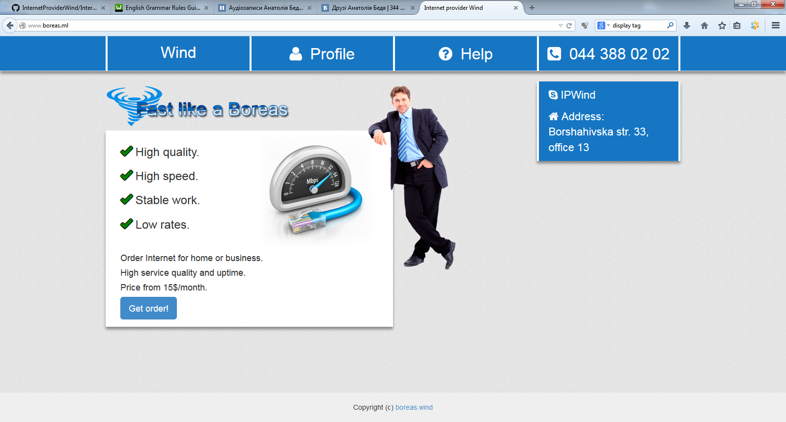

Figure 1 – Main page

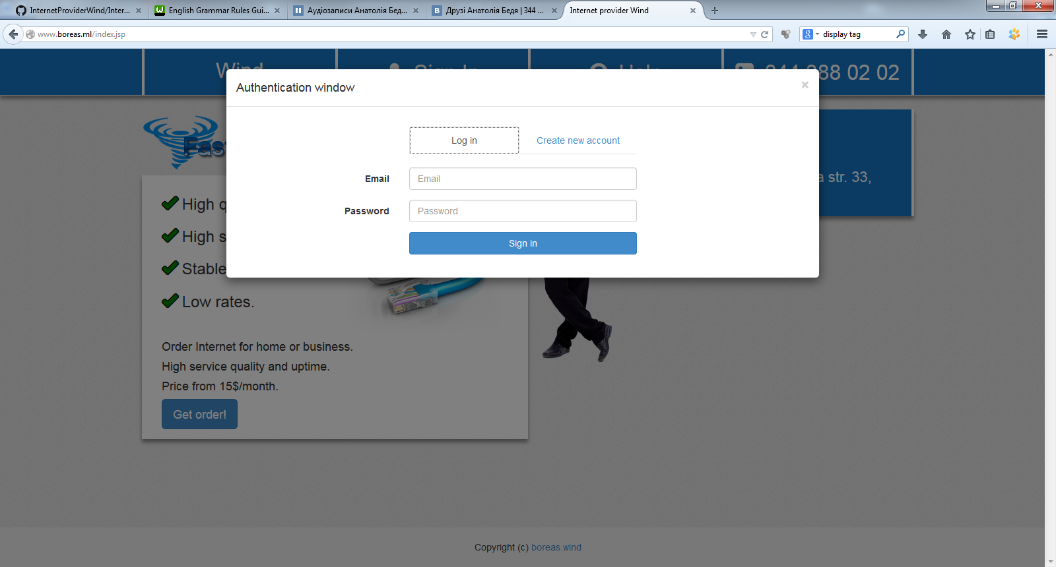

Figure 2 – Authentication page

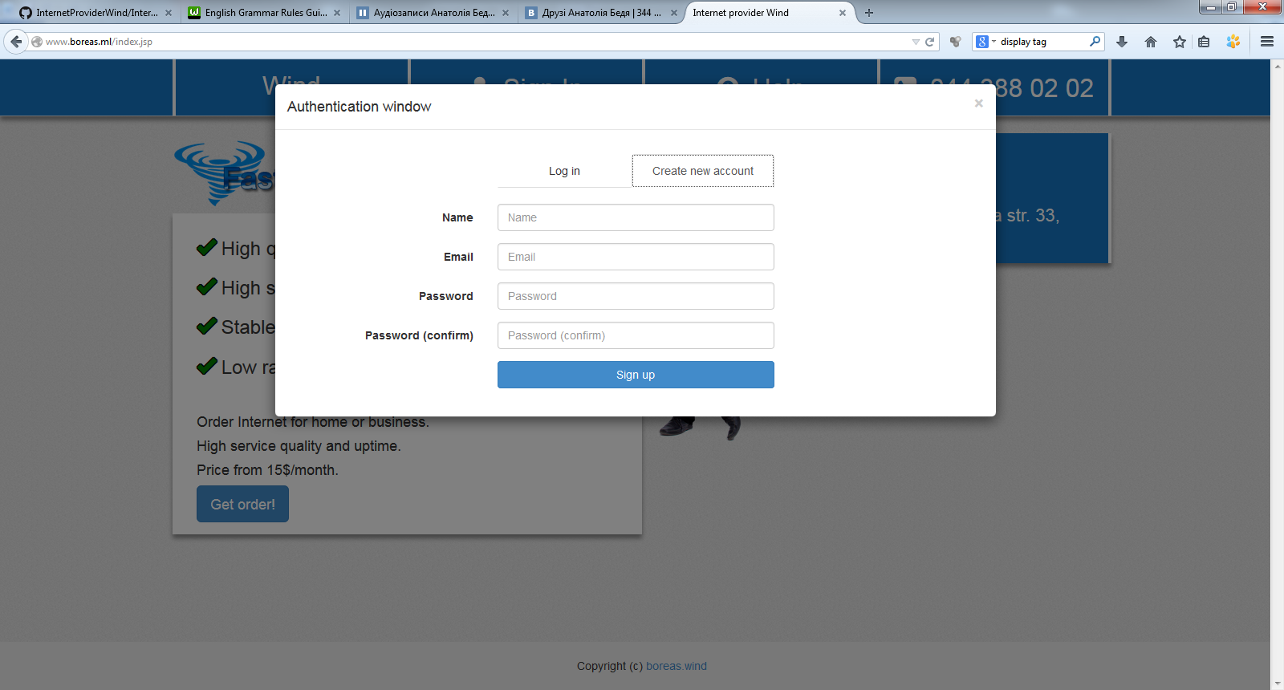

Figure 3 – Registration page

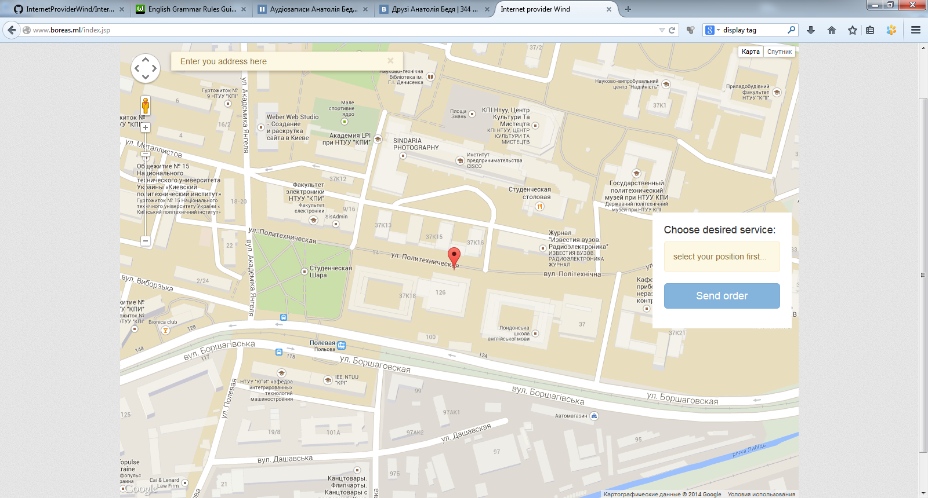

Figure 4 – Get order page

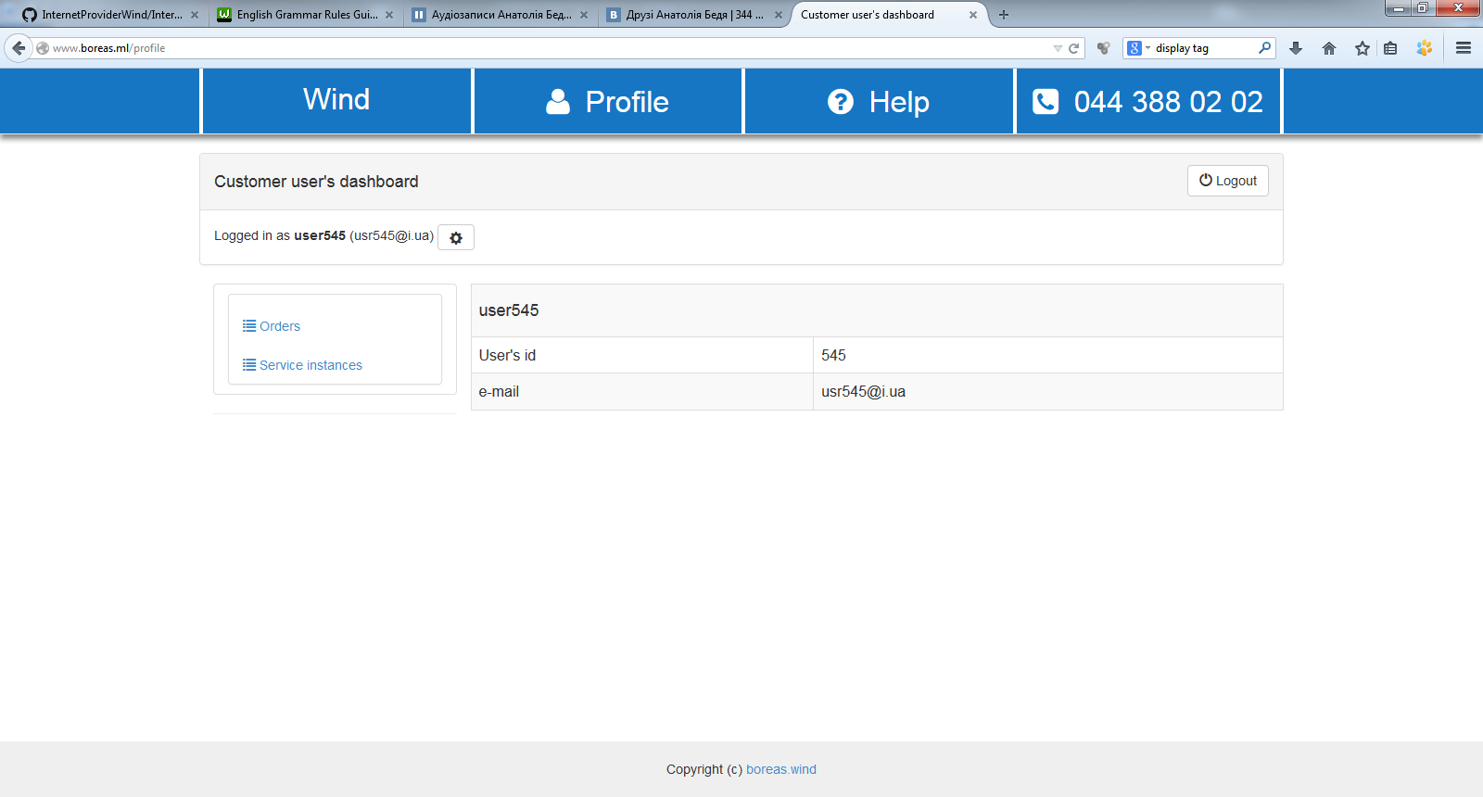

Figure 5 – Customer user’s dashboard

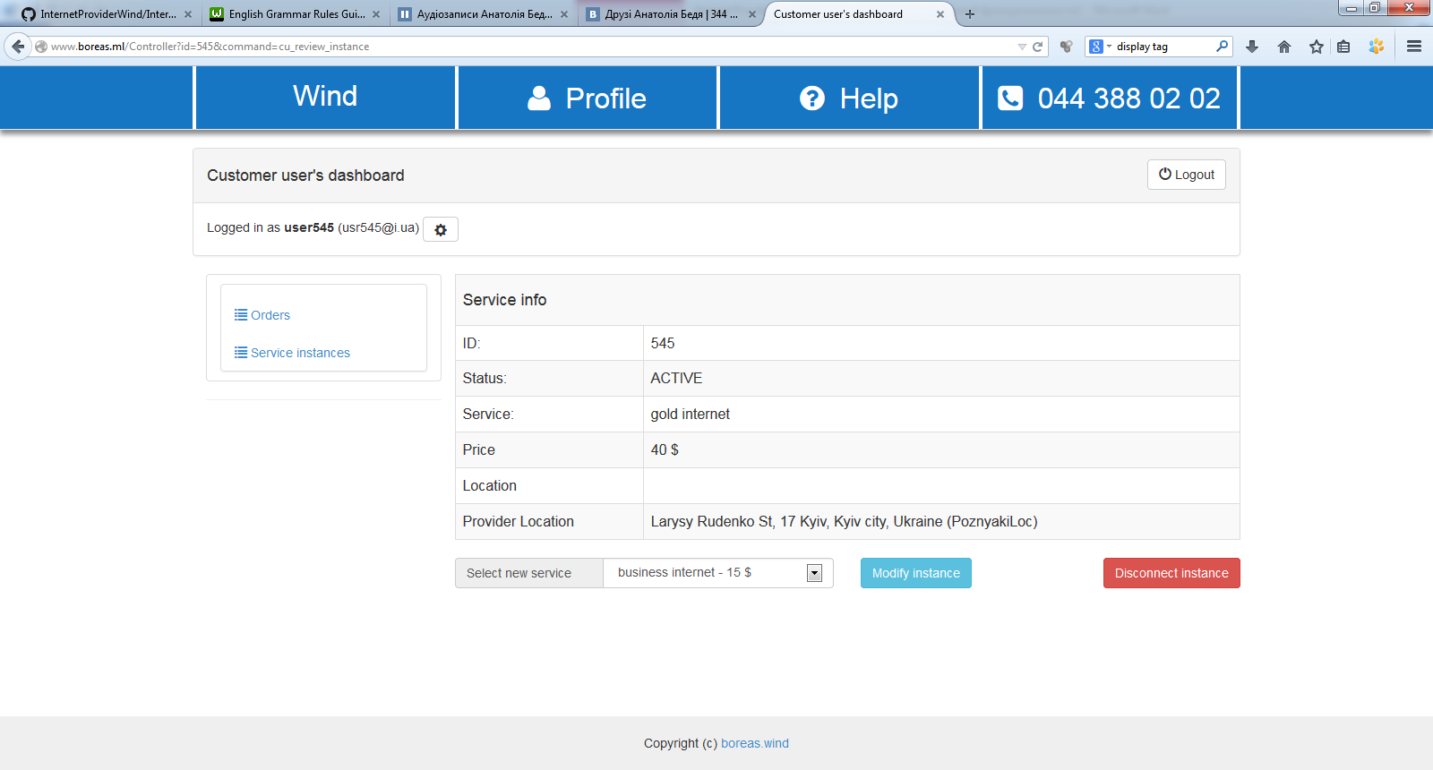

Figure 6 – User’s page for review Service Instance

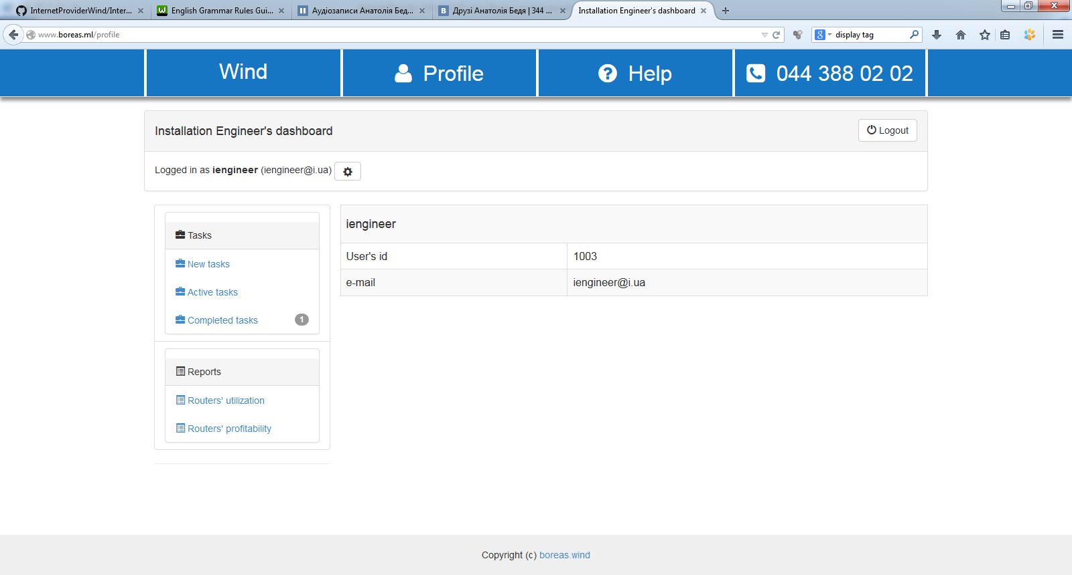

Figure 7 – Instalation engineer’s dashboard

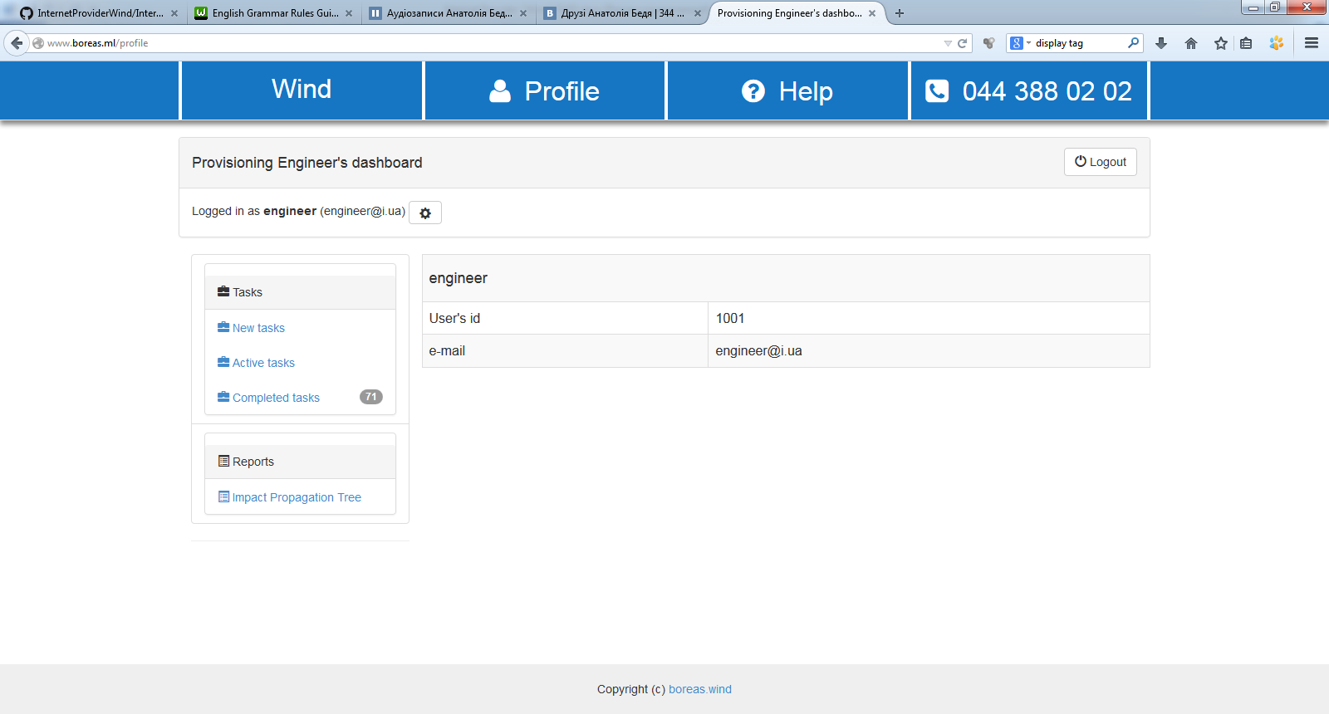

Figure 8 – Provisioning engineer’s dashboard

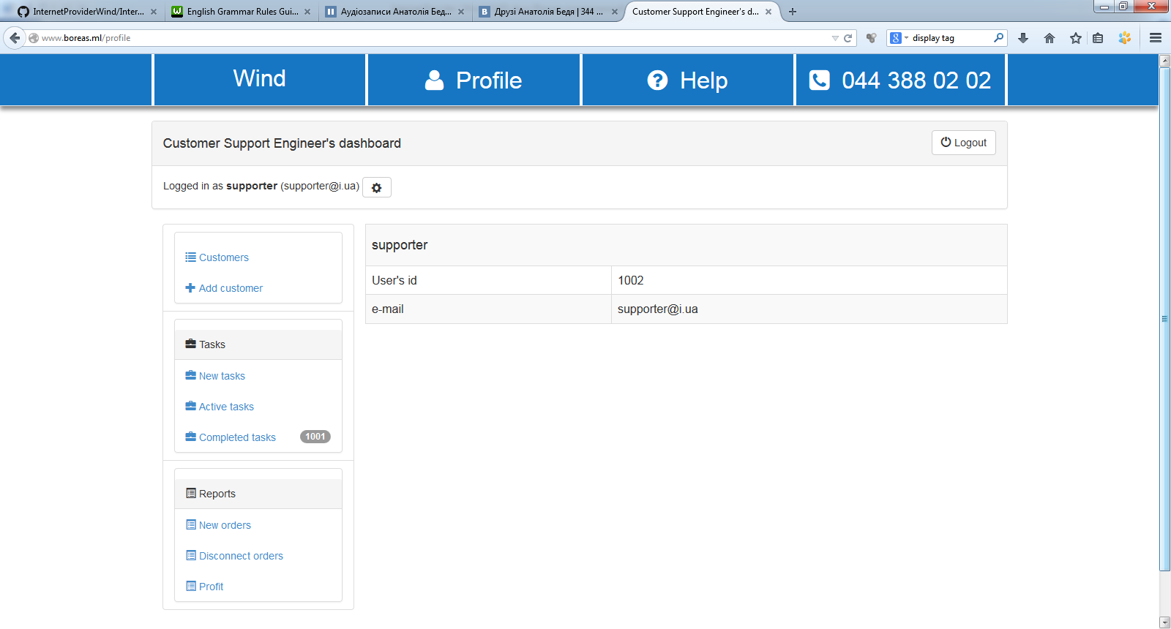

Figure 9 – Customer support engineer’s dashboard

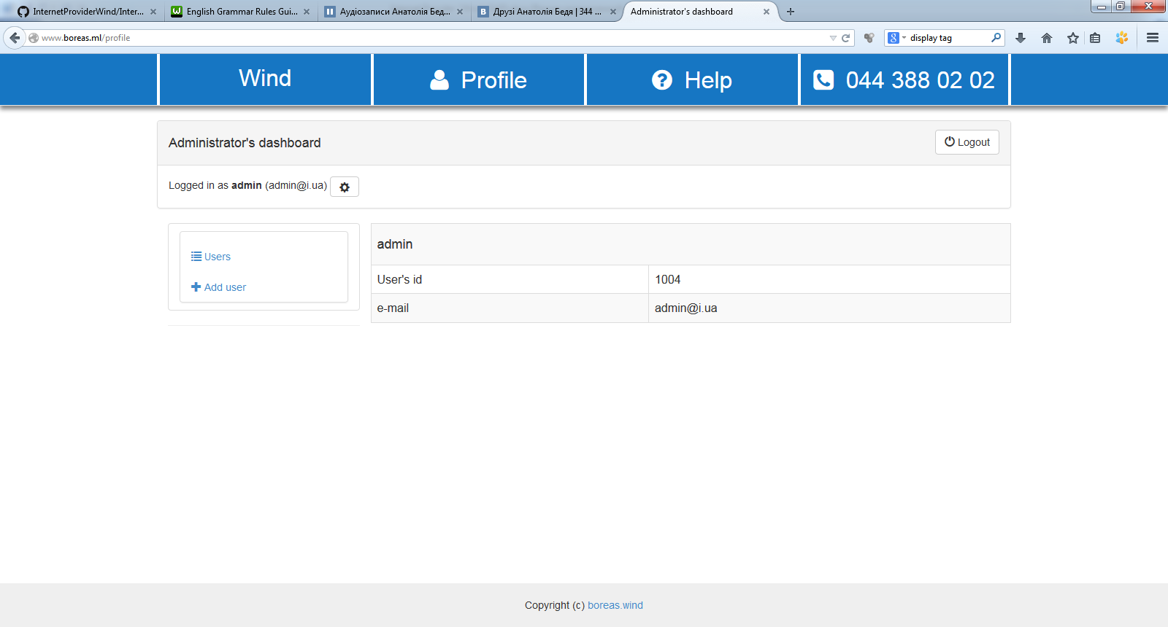

Figure 10 – Administrator’s dashboard

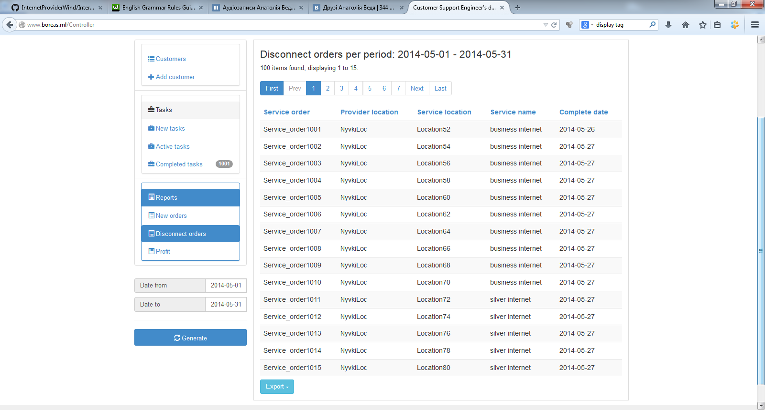

Figure 11 – Reports page

## Supported Business Processes



Figure 12 – Business processes creating and processing order BPMN 2.0

### Creating Employee Account

#### Description

|  |  |
| --- | --- |
| Use Case ID | WIND.UC.001 |
| Use Case Name | Creating Employee Account |
| Description | Administrator create Employee Account |
| Activate | Administrator has initiated the process of creation employee account. |
| Pre-conditions | ─ |
| Post-conditions | Employee Accounts is created and Employee is Registered |

#### Flow diagram



Figure 13─ Creating Customer Account Flow Diagram

#### Base Flow

| Step # | Actor | Action | Description |
| --- | --- | --- | --- |
| 1 | Administrator | Initiate Employee Account Creation | Administrator initiates Employee Account creation. |
| 2 | System | Display The Employee Account Creation Window | System displays the Employee Account creation window. |
| 3 | Administrator | Choose Group Of Employees | Administrator chooses group of employees |
| 4 | Administrator | Input Information About Employee | Administrator inputs information about employee |
| 5 | Administrator | Initiate Saving Data | Administrator initiates saving data |
| 6 | System | Validates Fields | System validates fields to correctly entry |
| 7 | System | Perform a Employee Duplication Check | System performs a Employee duplication check |
| 8.1 8.2 | System | Save Employee Account & Register Employee As Employee From Chosen Group | System saves Employee Account & System registers Employee as employee from chosen group |

#### Alternative Flow 1

| Step# | Actor | Action | Description |
| --- | --- | --- | --- |
|  |  |  | Entry Point:  Step #6 of the Base Flow: Validates Fields |
| 1 | System | Highlights Parameters | System highlights parameters with incorrect inputting and parameters which are necessary to be filled in |
|  |  |  | Join:  Step #4 of the Base Flow: Input Information About Employee |

#### Alternative Flow 2

| Step# | Actor | Action | Description |
| --- | --- | --- | --- |
|  |  |  | Entry Point:  Step #6 Perform a User Duplication Check |
| 1 | System | Displays Information About Incorrect Data | System displays information about incorrect data (existence of the same employee) |
|  |  |  | Join:  Step #4 of the Base Flow: Input Information About Employee |

### Creating Customer Accounts

#### Description

|  |  |
| --- | --- |
| Use Case ID | WIND.UC.002 |
| Use Case Name | Creating Customer Account |
| Description | Describes the process of Customer registration and Customer Account creation |
| Activate | User has initiated the process of registration and creation account. |
| Pre-conditions | Unregistered User |
| Post-conditions | Customer Account is created and Registered User as Customer |

#### Flow diagram



Figure 14─ Creating Customer Account by Customer Flow Diagram

#### Base Flow

| Step # | Actor | Action | Description |
| --- | --- | --- | --- |
| 1 | User | Presses Registration Button | Unregistered User presses registration button. |
| 2 | System | Display Customer Registration Window | System displays the Customer registration window |
| 3 | User | Inputs Information | User inputs information about yourself |
| 4 | User | Initiate Saving Data | User initiates saving data |
| 5 | System | Validates Fields | System validates fields to correctly entry |
| 6 | System | Perform a User Duplication Check | System performs a User duplication check |
| 7.1 7.2 | System | Save Customer Account& Registers User As Customer | System saves Customer Account & System registers User as Customer |

#### Alternative Flow 1

| Step# | Actor | Action | Description |
| --- | --- | --- | --- |
|  |  |  | Entry Point:  Step #5 of the Base Flow: Validates Fields |
| 1 | System | Highlights Parameters | System highlights parameters with incorrect inputting and parameters which are necessary to be filled in |
|  |  |  | Join:  Step #3 of the Base Flow: Inputs Information |

#### Alternative Flow 2

| Step# | Actor | Action | Description |
| --- | --- | --- | --- |
|  |  |  | Entry Point:  Step #6 Perform a User Duplication Check |
| 1 | System | Displays Information About Incorrect Data | System displays information about incorrect data (existence of the same) |
|  |  |  | Join:  Step #3 of the Base Flow: Inputs Information |

#### Alternative Flow 3

| Step# | Actor | Action | Description |
| --- | --- | --- | --- |
|  |  |  | Entry Point:  Step #6 Perform a User Duplication Check |
| 1 | System | Displays Information About Incorrect Data | System displays information about incorrect data (existence of the same) |
|  |  |  | Join: End |

### Blocking Accounts

#### Description

|  |  |
| --- | --- |
| Use Case ID | WIND.UC.003 |
| Use Case Name | Blocking Accounts |
| Description | Describes the process of Blocking Accounts by Administrator |
| Activate | Administrator has initiated the process of blocking accounts. |
| Pre-conditions | ─ |
| Post-conditions | Customer Account is created and Registered User as Customer |

#### Flow diagram



Figure 15─ Blocking Accounts Flow Diagram

#### Base Flow

| Step # | Actor | Action | Description |
| --- | --- | --- | --- |
| 1 | Administrator | Block User Account | Administrator blocks User account. |
| 2 | System | Change User Account Status | System change User Account Status from "Active" to "Blocked" |

### Changing Customer Password

#### Description

|  |  |
| --- | --- |
| Use Case ID | WIND.UC.004 |
| Use Case Name | Changing Customer Password |
| Description | Describes the process of Changing Customer Password by Customer User |
| Activate | Customer User has initiated the process of changing his password. |
| Pre-conditions | Customer User forgets own password |
| Post-conditions | Customer Password is changed |

#### Flow diagram



Figure 16 ─ Changing Customer Password Flow Diagram

#### Base Flow

| Step # | Actor | Action | Description |
| --- | --- | --- | --- |
| 1 | Customer User | Presses Changing Password button | Customer User initiates process of changing password |
| 2 | System | Display Customer Changing Password Window | System displays the Customer Changing password window |
| 3 | Customer User | Inputs Login & Password Information | User inputs Login & Password information |
| 4 | System | Validates Fields | System validates fields to correctly entry |
| 5 | Customer User | Inputs & Confirms new Password Information | Customer User inputs & confirms new password |
| 6 | System | Validates new Password Fields | System validates equality between the new password and confirmed password |
| 7 | System | Saves new Customer Password | System saves new Customer password |

#### Alternative Flow 1

| Step# | Actor | Action | Description |
| --- | --- | --- | --- |
|  |  |  | Entry Point:  Step #6 of the Base Flow: Validates new Password Fields |
| 1 | System | Displays information about unequal password | System displays information about unequal password |
|  |  |  | Join:  Step #3 of the Base Flow: Inputs & Confirms new Password Information |

#### Alternative Flow 2

| Step# | Actor | Action | Description |
| --- | --- | --- | --- |
|  |  |  | Entry Point:  Step #4 of the Base Flow: Validates Fields |
| 1 | System | Highlights parameters | System highlights parameters with incorrect inputting and parameters which are necessary to be filled in |
| 2 | Customer User | Approves Inputting his Login/password Data second time | Customer User approves, that he want to Input his Login/password Data second time |
|  |  |  | Join:  Step #2 of the Base Flow: Display Customer Changing Password Window |

#### Alternative Flow 3

| Step# | Actor | Action | Description |
| --- | --- | --- | --- |
|  |  |  | Entry Point:  Step #1 of the Alternative Flow 2: Validates Fields |
| 1 | Customer User | Disapproves Inputting his Login/password Data second time | User disapproves, that he want to Input his Login/password Data second time |
| 2 | Customer User | Contacts with Customer Engineer about password changing | Customer contacts with Customer Support Engineer that he/she changes the password |
| 3 | Customer Support Engineer | Changes Customer Password | Customer Support Engineer changes Customer password |
| 4 | Customer Support Engineer | Sends new Customer Password to user | Customer Support Engineer send new Customer password to Customer User |
|  |  |  | Join:  Step #7 of the Base Flow: Display Customer Changing Password Window |

### Review Service Instance

#### Description

|  |  |
| --- | --- |
| Use Case ID | WIND.UC.005 |
| Use Case Name | Review Service Instance |
| Description | Describes the process of Reviewing Service Instance by Customer Support Engineer |
| Activate | Customer Support Engineer has initiated the process of reviewing service instance. |
| Pre-conditions | Service Instance existed in the System |
| Post-conditions | Service Instance is reviewed. |

#### Flow diagram



Figure 17─ Review Service Instance Flow Diagram

#### Base Flow

| Step # | Actor | Action | Description |
| --- | --- | --- | --- |
| 1 | Customer Support Engineer | Initiates process of reviewing SI | Customer Support Engineer initiates process of reviewing SI for Customer User navigating to the 'Customers' tab |
| 2 | System | Displays List of existing Customer Accounts | System displays the list of existing Customer Accounts |
| 3 | Customer Support Engineer | Selects one of the Accounts & Requests to view SI | Customer Support Engineer selects one of the accounts from the list and requests to view Customer SI |
| 4 | System | Displays parameters SI of the selected Accounts | System displays parameters SI of the selected Customer account |

### 

### Review Service Order

#### Description

|  |  |
| --- | --- |
| Use Case ID | WIND.UC.006 |
| Use Case Name | Review Service Order |
| Description | Describes the process of Reviewing Service Order by Customer Support Engineer |
| Activate | Customer Support Engineer has initiated the process of reviewing service order. |
| Pre-conditions | Service Order in the System |
| Post-conditions | Service Order is reviewed. |

#### Flow diagram



Figure 18─ Review Service Order Flow Diagram

#### Base Flow

| Step # | Actor | Action | Description |
| --- | --- | --- | --- |
| 1 | Customer Support Engineer | Initiates process of reviewing SO | Customer Support Engineer initiates process of reviewing SO for Customer User |
| 2 | System | Displays List, which can review Customer SO | System displays the list of options which you can review Customer SO |
| 3 | Customer Support Engineer | Selects one of the Accounts & Requests to view SO | Customer Support Engineer selects one of the accounts from the list and requests to view Customer SO |
| 4 | System | Displays parameters SO of the selected Account | System displays parameters SO of the selected Customer account |

#### Alternative Flow 1

| Step# | Actor | Action | Description |
| --- | --- | --- | --- |
|  |  |  | Entry Point:  Step #2 of the Base Flow: Displays List, which can review Customer SO |
| 1 | System | Displays list of New SO | System displays list of New SO with required parameters |

#### Alternative Flow 2

| Step# | Actor | Action | Description |
| --- | --- | --- | --- |
|  |  |  | Entry Point:  Step #2 of the Base Flow: Displays List, which can review Customer SO |
| 1 | System | Displays list of Disconnect SO | System displays list of Disconnect SO with required parameters |

### Creating Service Order

#### Description

|  |  |
| --- | --- |
| Use Case ID | WIND.UC.007 |
| Use Case Name | Creating Service Order |
| Description | Describes the process of Customer Service Order |
| Activate | User has initiated the process of creation account Service Order. |
| Pre-conditions | ─ |
| Post-conditions | Service Order is created |

#### Flow diagram



Figure 19─ Creating Customer Account Flow Diagram

#### Base Flow

| Step # | Actor | Action | Description |
| --- | --- | --- | --- |
| 1 | User/CSE | Initiates Service Order creation |  |
| 2 | System | Displays The Service Order Window In Entry Mode |  |
| 3 | User/CSE | Selects Service Location |  |
| 4 | System | Indicates Service Location On Map and displays List of available Services with prices |  |
| 5 | User/CSE | Selects Service and presses ‘Proceed’ button |  |
| 6 | System | Checks user authorized or not:   1. If user authorized in the system, the system:  * Creates Service Order with Status ‘Entering’ * Populates the next parameters: Order ID, User ID, Order ID, User ID, Serice ID,Service Inctance ID, Service Location ID, Provider Location ID, status, senario, Enterdata  1. If user didn’t authorize in the system, the system navigates user to the authorization/registration window (go to Alternative Flow 1) |  |
| 7 | User/CSE | Checks all parameters |  |
| 8 | User/CSE | Presses ‘Confirm order’ button | If all SO parameters satisfy User and correct then User/CSE presses ‘Confirm order’ button else go to Alternative Flow 3 |
| 9 | System | 1. Changes Status for Service Order to ‘Processing’ and creates Service Instance with Status= ‘Planned’ Changes Status for Service Order to ‘Pending for Activation’. 2. Sends email notification to the responsible group with the next parameters: Task ID, User ID, Type, Status, Role_ID, Service_order_id |  |

#### Alternative Flow 1

| Step# | Actor | Action | Description |
| --- | --- | --- | --- |
|  |  |  | Entry Point:  Step #6 of the Base Flow: Checks the User authorization |
| 1 | System | Navigates user to the authorization/registration window | System navigates user to the authorization/registration window |
| 2 |  |  | If user registered in the system then WIND.US.024 User Logs In else Alternative flow 2 |
|  |  |  | Join:  Step #7 of the Base Flow: Checks all parameters |

#### Alternative Flow 2

| Step# | Actor | Action | Description |
| --- | --- | --- | --- |
|  |  |  | Entry Point:  Step #1 of the Alternative Flow 1: Navigates user to the authorization/registration window |
| 1 |  |  | WIND.US.002 Creating Customer Accounts |
|  |  |  | Join:  Step #7 of the Base Flow: Checks all parameters |

#### Alternative Flow 3

| Step# | Actor | Action | Description |
| --- | --- | --- | --- |
|  |  |  | Entry Point:  Step # 7 of the Base Flow: Checks all parameters |
| 1 |  |  | WIND.US.025 Cancel Server Order |
|  |  |  | Join: END |

### Creating Customer Account by Customer Support Engineer

#### Description

|  |  |
| --- | --- |
| Use Case ID | WIND.UC.008 |
| Use Case Name | Creating Customer Account by Customer Support Engineer |
| Description | Describes the process of Creating Customer Account by Customer Support Engineer |
| Activate | Client contacts with Customer Support Engineer that he/she create him/her Customer Account |
| Pre-conditions | ─ |
| Post-conditions | Customer Support Engineer created new Customer Account. |

#### Flow diagram



Figure 20─ Creating Customer Account by Customer Support Engineer Flow Diagram

#### Base Flow

| Step # | Actor | Action | Description |
| --- | --- | --- | --- |
| 1 | User | Contacts with Customer Support Engineer for Customer Account creation | User contacts with Customer Support Engineer that he creates him Customer Account |
| 2 | Customer Support Engineer | Initiates process of creating Customer Account | Customer Support Engineer initiates process of creating Customer Account |
| 3 | System | Displays the Customer registration window | System displays the Customer registration window |
| 4 | Customer Support Engineer | Inputs information about client | Customer Support Engineer inputs information about client |
| 5 | Customer Support Engineer | Initiates saving data | Customer Support Engineer initiates saving data |
| 6 | System | Validates fields | System validates fields to correctly entry |
| 7 | System | Performs a User duplication check | System performs a User duplication check |
| 8 | System | Saves Customer Account | System saves customer account |

#### Alternative Flow 1

| Step# | Actor | Action | Description |
| --- | --- | --- | --- |
|  |  |  | Entry Point:  Step #6 of the Base Flow: Validates fields |
| 1 | System | Highlights parameters which are necessary filled in & inputted incorrect | System highlights parameters with incorrect inputting and parameters which are necessary to be filled in |
|  |  |  | Join:  Step #4 of the Base Flow: Inputs Information about Client |

#### Alternative Flow 2

| Step# | Actor | Action | Description |
| --- | --- | --- | --- |
|  |  |  | Entry Point:  Step #7 of the Base Flow: Performs a User duplication check |
| 1 | System | Displays information about incorrect data | System displays information about incorrect data (existence of the same user) |
|  |  |  | Join:  Step #4 of the Base Flow: Inputs Information about Client |

#### Alternative Flow 3

| Step# | Actor | Action | Description |
| --- | --- | --- | --- |
|  |  |  | Entry Point:  Step #7 of the Base Flow: Performs a User duplication check |
| 1 | System | Displays information about incorrect data | System displays information about incorrect data (existence of the same user) |

### Service Order Processing

#### Description

|  |  |
| --- | --- |
| Use Case ID | WIND.UC.009 |
| Use Case Name | Service Order Processing |
| Description | Describes Service Order Processing |
| Activate | System generates tasks for responsible group. |
| Pre-conditions | Service Order is created |
| Post-conditions | Service Order is completed |

#### Flow diagram



Figure 21─ Creating Customer Account Flow Diagram

#### Base Flow

| Step # | Actor | Action | Description |
| --- | --- | --- | --- |
| 1 |  |  | WIND.UC.011 Creating New Circuit |
| 2 | System | Sends email notification to the responsible group with the next parameters: Task ID, Type, Status | System sends email notification to the responsible group with the next parameters: Task ID, Type, Status |
| 3 | Installation Engineer | Receives email notification and navigates to Tasks tab | Installation Engineer receives email notification and navigates to Tasks tab |
| 4 | System | Displays all Tasks which assigned to the Installation Group | System displays all Tasks which assigned to the Installation Group |
| 5 | Installation Engineer | Presses button on the Task | Installation Engineer presses button on the Task |
| 6 | System | System displays required Task parameters | System displays the next Task parameters:  Task ID, User ID, Type, Status, Role_ID, Service_order_id |
| 7.1  7.2 | Installation Engineer | 1. Inputs cable name 2. Presses ‘Create cable’ button | 1. Installation Engineer inputs cable name 2. Installation Engineer presses ‘Create cable’ button |
| 8 | Installation Engineer | Presses ‘Complete’ button | Installation Engineer presses ‘Complete’ button |
| 9 | System | 1. Performs parameters validation 2. Takes into account dependencies between Cable and Circuit Sends email notification to the Customer with the service instance and service order parameters | 1. System performs parameters validation 2. System takes into account dependencies between Cable and Circuit Sends email notification to the Customer with the service instance and service order parameters |
| 10 | Installation Engineer | Changes Status for Service Order to ‘Completed’. | Installation Engineer changes Status for Service Order to ‘Completed’. |
| 11 |  |  | WIND.UC.013 Bill send |

### Creating New Router in System

#### Description

|  |  |
| --- | --- |
| Use Case ID | WIND.UC.010 |
| Use Case Name | Creating New Router in System |
| Description | Describes the process of Creation New Router in System |
| Activate |  |
| Pre-conditions | User/CSE initiated New Router creation process |
| Post-conditions | New Router is created. |

#### Flow diagram



Figure 22─ Creating New Router in System Flow Diagram

#### Base Flow

| Step # | Actor | Action | Description |
| --- | --- | --- | --- |
| 1 | System | Creates Task to Installation Engineer Group | System creates the Task to Installation Engineer Group. |
| 2 | System | Sends email notification to the responsible group with the next parameters: Task ID, Type, Status | System sends email notification to the responsible group with the next parameters: Task ID, Type, Status |
| 3 | Installation Engineer | Receives email notification and navigates to Tasks tab | Installation Engineer receives email notification and navigates to Tasks tab |
| 4 | System | Displays all Tasks which assigned to the Installation Group | System displays all Tasks which assigned to the Installation Group |
| 5 | Installation Engineer | Presses button on the Task | Installation Engineer presses button on the Task |
| 6 | System | System displays required Task parameters | System displays the next Task parameters:  Task ID, User ID, Type, Status, Role_ID, Service_order_id |
| 7.1  7.2 | Installation Engineer | 1. Inputs device name 2. Presses ‘Create device’ button | 1. Installation Engineer inputs device name 2. Installation Engineer presses ‘Create device’ button |
| 8 | System | Performs parameters validation | System performs parameters validation |
| 9 | System | Completes particular Task | System completes particular Task |

### Creating New Circuit in System

#### Description

|  |  |
| --- | --- |
| Use Case ID | WIND.UC.011 |
| Use Case Name | Creating New Circuit in System |
| Description | Describes the process of Creating New Circuit in System by Provisioning Engineer |
| Activate | System has initiated the process of creation new Circuit. |
| Pre-conditions | New Circuit in System task initialized |
| Post-conditions | New Circuit is created |

#### Flow diagram



Figure 23 ─ Creating New Circuit in System Flow Diagram

#### Base Flow

| Step # | Actor | Action | Description |
| --- | --- | --- | --- |
| 1 | System | Sends email notification to the responsible group with required parameters | System sends email notification to the responsible group with the next parameters: Task ID, User ID, Type, Status, Role_ID, Service_order_id |
| 2 | Provisioning Engineer | Receives email notification and navigates to Tasks tab | Provisioning Engineer receives email notification and navigates to Tasks tab |
| 3 | System | Displays all Tasks which assigned to the Provisioning Group | System displays all Tasks which assigned to the Provisioning Group |
| 4 | Provisioning Engineer | Presses button on the Task | Provisioning Engineer presses button on the Task |
| 5 | System | System displays the required Task parameters | System displays the next Task parameters:  Task ID, User ID, Type, Status, Role_ID, Service_order_id |
| 6.1  6.2 | System | 1. Performs device availability check 2. Populates Device ID and Ports ID, Port.Status = In Use automatically | Performs device availability check:   1. If device is available, the system populates Device ID and Ports ID, Port.Status = In Use automatically 2. If device is not available, the system displays popup window ‘Device is not available for the current Location. Please create New Device’ (go to Alternative Flow 1) |
| 7 | System | Displays Circuit Creation window | System displays Circuit Creation window |
| 8 | Provisioning Engineer | Refers the assigned port to Service Instance and links Circuit to Port | Provisioning Engineer refers the assigned port to Service Instance and links Circuit to Port |
| 9 | Provisioning Engineer | Populates all mandatory parameters and presses populates all mandatory parameters and presses ‘Setup circuit’ button | Provisioning Engineer populates all mandatory parameters and presses ‘Setup circuit’ button |
| 10 | System | Performs parameters validation | System performs parameters validation (Does Provisioning Engineer perform Task?)  If PE does not perform Task go to Alternative Flow 2 |
| 11 | System | Completes particular Task | System completes particular Task |

#### Alternative Flow 1

| Step# | Actor | Action | Description |
| --- | --- | --- | --- |
|  |  |  | Entry Point:  Step #6.1 of the Base Flow: Performs device availability check |
| 1 |  |  | WIND.UC.010 Creating New Router in System |
|  |  |  | Join:  Step #6.2 of the Base Flow: Populates Device ID and Ports ID, Port.Status = In Use automatically |

#### Alternative Flow 2

| Step# | Actor | Action | Description |
| --- | --- | --- | --- |
|  |  |  | Entry Point:  Step #10 of the Base Flow: Performs parameters validation |
| 1 | System | Suspends particular Task | System suspends particular Task |
| 2 | System | Reassigns particular Task between Provisioning Engineers | System reassigns particular Task from this Provisioning Engineer to another Provisioning Engineer under defined Provisioning Engineer Groups |
|  |  |  | Join:  Step #1 of the Base Flow: Sends email notification to the responsible group with required parameters |

### Removing the Circuit in System

#### Description

|  |  |
| --- | --- |
| Use Case ID | WIND.UC.012 |
| Use Case Name | Removing the Circuit in System |
| Description | Describes the process of Removing the Circuit in System by Provisioning Engineer |
| Activate | System has initiated the process of removing the Circuit. |
| Pre-conditions | Removing the Circuit in System task initialized |
| Post-conditions | The Circuit is removed |

#### Flow diagram



Figure 24 ─ Removing Circuit in System Flow Diagram

#### Base Flow

| Step # | Actor | Action | Description |
| --- | --- | --- | --- |
| 1 | System | Creates Task to Provisioning Engineer Group | System creates the Task to Provisioning Engineer Group |
| 2 | System | * Sends email notification to the Provisioning Engineer group with the next parameters: Task ID, Type, Status | * System sends email notification to the Provisioning Engineer group with the next parameters: Task ID, Type, Status |
| 3 | Provisioning Engineer | Receives email notification and navigates to Tasks tab | Provisioning Engineer receives email notification and navigates to Tasks tab |
| 4 | Provisioning Engineer | Provisioning Engineer Group presses button on the Task | Provisioning Engineer Group presses button on the Task |
| 5 | System | Displays the next Task parameters: Task ID, Type, Status, Role_ID, Service_instance_id | System displays the next Task parameters: Task ID, Type, Status, Role_ID, Service_instance_id |
| 6 | System changes | Status of Service Order from ‘Entering’ to ‘Processing’ | System changes Status of Service Order from ‘Entering’ to ‘Processing’ |
| 7 | Provisioning Engineer | Removes the circuit | Provisioning Engineer removes the circuit |
| 8 | Provisioning Engineer | Presses ‘Complete’ button | Provisioning Engineer presses 'Complete' button |
| 9 | System | Completes particular Task | System completes particular Task |

#### Alternative Flow

| Step# | Actor | Action | Description |
| --- | --- | --- | --- |
|  |  |  | Entry Point:  Step #8 of the Base Flow: Presses ‘Complete’ button |
| 1 | System | Suspends particular Task | System suspends particular Task |
| 2 | System | Reassigns particular Task between Provisioning Engineers | System reassigns particular Task from this Provisioning Engineer to another Provisioning Engineer under defined Provisioning Engineer Groups |
|  |  |  | Join:  Step #4 of the Base Flow: Provisioning Engineer Group presses button on the Task |

### Bill Sending

#### Description

|  |  |
| --- | --- |
| Use Case ID | WIND.UC.011 |
| Use Case Name | Bill Sending in System |
| Description | Describes the process of Bill Sending in System by Customer Support Engineer |
| Activate | System has initiated the process of sending the Bill. |
| Pre-conditions | Bill Sending task initialized |
| Post-conditions | The Bill sent |

#### Flow diagram



Figure 25 ─ Bill Sending in System Flow Diagram

#### Base Flow

| Step # | Actor | Action | Description |
| --- | --- | --- | --- |
| 1 | System | Creates Task to Customer Support Engineer Group | System creates the Task to Customer Support Engineer Group |
| 2 | System | Sends email notification to CSE Group with the required parameters | System sends email notification to the responsible group with the next parameters: Task ID, Type, Status |
| 3 | Customer Support Engineer | Receives email notification and navigates to Tasks tab | Customer Support Engineer receives email notification and navigates to Tasks tab |
| 4 | System | Displays all Tasks which assigned to the Customer Support Engineer Group | System displays all Tasks which assigned to the Customer Support Engineer Group |
| 5 | Customer Support Engineer | Presses button on the Task | Customer Support Engineer presses button on the Task |
| 6 | System | System displays required Task parameters | System displays the next Task parameters:  Task ID, User ID, Type, Status, Role_ID, Service_order_id |
| 7 | Customer Support Engineer | Forms letter as report with current Bill by SO | Customer Support Engineer forms letter as report with current bill by Service Order. |
| 8 | Customer Support Engineer | Sends letter with current Bill by SO | Customer Support Engineer sends letter with current bill by Service Order |
| 9 | Customer Support Engineer | Presses ‘Complete’ button | Installation Engineer presses ‘Send bill’ button |
| 10 | System | Performs parameters validation | System performs parameters validation (Does Provisioning Engineer perform Task?)  If PE does not perform Task go to Alternative Flow |
| 11 | System | Completes particular Task | System completes particular Task |

#### Alternative Flow

| Step# | Actor | Action | Description |
| --- | --- | --- | --- |
|  |  |  | Entry Point:  Step #10 of the Base Flow: Performs parameters validation |
| 1 | System | Suspends particular Task | System suspends particular Task |
| 2 | System | Reassigns particular Task between Provisioning Engineers | System reassigns particular Task from this Provisioning Engineer to another Provisioning Engineer under defined Provisioning Engineer Groups |
|  |  |  | Join:  Step #2 of the Base Flow: Sends email notification to CSE Group with the required parameters |

### Creating Service Instance

#### Description

|  |  |
| --- | --- |
| Use Case ID | WIND.UC.012 |
| Use Case Name | Creating Service Instance |
| Description | Describes the process of Service Instance creation in System |
| Activate | System has initiated the process of Service Instance creation |
| Pre-conditions | Service Order created |
| Post-conditions | Service Instance created |

#### Flow diagram



Figure 26 ─ Creating Service Instance Flow Diagram

#### Base Flow

| Step # | Actor | Action | Description |
| --- | --- | --- | --- |
| 1 | System | Creates the Service Instance with Status = ‘Planned’ | System creates the Service Instance with Status = ‘Planned’ |
| 2 |  | Service Order Processing | WIND.UC.007 Service Order Processing |
| 3 | System | Changes the Status of SI to ‘Active’ | System changes the Status of Service Instance from ‘Planned’ to ‘Active’ |
| 4 | System | Completes particular Task | System completes particular Task |

### Modifying Parameters for Service Instance

#### Description

|  |  |
| --- | --- |
| Use Case ID | WIND.UC.015 |
| Use Case Name | Modifying Parameters for Service Instance |
| Description | Describes the process of Modifying Parameters for Service Instance in System |
| Activate | Customer User/CSE has initiated the process of Modifying Parameters for Service Instance |
| Pre-conditions | Customer User/CSE initiated modification for Service Instance |
| Post-conditions | Parameters for Service Instance modified |

#### Flow diagram



Figure 27 ─ Modifying Parameters for Service Instance Flow Diagram

#### Base Flow

| Step # | Actor | Action | Description |
| --- | --- | --- | --- |
| 1 | Customer User/CSE | Initiates process of updating configuration of the subscribed SI. | Customer User initiates process of updating configuration of the subscribed Service Instance. |
| 2.1  2.2 | System | * Creates new SO with Status ‘Entering and Type = Modify * Populates all parameters for Service Instance | System Creates new SO with Status ‘Entering and Type = Modify and populates all parameters for Service Instance |
| 3.1 3.2 | User/CSE | * Modifies parameters for particular Service Instances * Presses ‘Modify’ button | User/CSE modifies parameters for particular Service Instances and presses ‘Modify’ button |
| 4 | System | Performs parameters validation | System performs parameters validation |
| 5 | System | Creates the Task to Provisioning Engineer Group | System creates the Task to Provisioning Engineer Group |
| 6.1-  6.5 | System | * Performs parameters validation * Changes the Status of Service Order from 'Entering' to ‘Processing’ * Creates the Task with Type = Modify * Assigns Task to Provisioning Engineer Group * Sends email notification to the Provisioning Engineer group with the next parameters: Task ID, Type, Status | * System performs parameters validation * System changes the Status of Service Order from 'Entering' to ‘Processing’ * System creates the Task with Type = Modify * System assigns Task to Provisioning Engineer Group * System sends email notification to the Provisioning Engineer group with the next parameters: Task ID, Type, Status |
| 7 | Provisioning Engineer | Receives email notification and navigates to Tasks tab | Provisioning Engineer receives email notification and navigates to Tasks tab |
| 8 | Provisioning Engineer | Provisioning Engineer Group presses button on the Task | Provisioning Engineer Group presses button on the Task |
| 9 | System | Displays the next Task parameters: Task ID, Type, Status, device_id(name), port_id(name), Customer location, Provider location | System displays the next Task parameters: Task ID, Type, Status, device_id(name), port_id(name), Customer location, Provider location |
| 10 | Provisioning Engineer | * Performs the Task * Presses ‘Complete’ button | Provisioning Engineer performs the Task and presses 'Complete' button |
| 11.1  11.2  11.3 | System | * Performs parameters validation * Updates new parameters for Service Instance * Changes Service Order Status to Completed |  |

#### Alternative Flow

| Step# | Actor | Action | Description |
| --- | --- | --- | --- |
|  |  |  | Entry Point:  Step #11.1 of the Base Flow: Performs parameters validation |
| 1 | System | Suspends particular Task | System suspends particular Task |
| 2 | System | Reassigns particular Task between Provisioning Engineers | System reassigns particular Task from this Provisioning Engineer to another Provisioning Engineer under defined Provisioning Engineer Groups |
|  |  |  | Join:  Step #6.5 of the Base Flow: Sends email notification to the Provisioning Engineer group with the next parameters: Task ID, Type, Status |

### Disconnect for Existing Service Instance

#### Description

|  |  |
| --- | --- |
| Use Case ID | WIND.UC.016 |
| Use Case Name | Disconnect for Existing Service Instance |
| Description | Describes the process of Disconnection for Existing Service Instance |
| Activate | Customer User/CSE has initiated the process of Disconnection for Existing Service Instance |
| Pre-conditions | Customer User/CSE initiated the process of disconnection for Existing Service Instance initialized |
| Post-conditions | Existing Service Instance disconnected |

#### Flow diagram



Figure 28 ─ Disconnect for Existing Service Instance Flow Diagram

#### Base Flow

| Step # | Actor | Action | Description |
| --- | --- | --- | --- |
| 1 | Customer User | Initiates process of disconnection the subscribed products and services. | Customer User initiates process of disconnecting the subscribed products and services. |
| 2 | System | * Creates a new Service Order with Status=‘Entering’ for a Customer User * Changes the Status of Service Instance from ‘Active’ to ‘Pending to disconnect’ | System creates a new Service Order with Status=‘Entering’ for a Customer User, System changes the Status of Service Instance from ‘Active’ to ‘Pending to disconnect’ |
| 3 |  |  | WIND.UC.012 Removing the Circuit in System |
| 4 | System | Creates the Task to Installation Engineer Group | System creates the Task to Installation Engineer Group. |
| 5 | System | * Sends email notification to the Installation Engineer group with the next parameters: Task ID, Type, Status | * System sends email notification to the Installation Engineer group with the next parameters: Task ID, Type, Status |
| 6 | Installation Engineer | Receives email notification and navigates to Tasks tab | Installation Engineer receives email notification and navigates to Tasks tab |
| 7 | System | Displays all Tasks which assigned to the Installation Engineer Group | System displays all Tasks which assigned to the Installation Engineer Group |
| 8 | Installation Engineer | Presses button on the Task | Installation Engineer presses button on the Task |
| 9 | System | Displays the next Task parameters: Task ID, Type, Status, device_id(name), port_id(name), Customer location, Provider location | System displays the next Task parameters: Task ID, Type, Status, device_id(name), port_id(name), Customer location, Provider location |
| 10 | Installation Engineer | Deletes Cable | Installation Engineer deletes Cable |
| 11 | Installation Engineer | Presses "Complete" button | Installation Engineer presses "Complete" button |
| 12 | System | Performs parameters validation | System performs parameters validation |
| 13 | System | Creates the Task to Provisioning Engineer Group. | System creates the Task to Provisioning Engineer Group. |
| 14 | System | Sends email notification to the Provisioning Engineer group with the next parameters: Task ID, Type, Status | System sends email notification to the Provisioning Engineer group with the next parameters: Task ID, Type, Status |
| 15 | Provisioning Engineer | Receives email notification and navigates to Tasks tab | Provisioning Engineer receives email notification and navigates to Tasks tab |
| 16 | System | Displays all Tasks which assigned to the Provisioning Engineer Group | System displays all Tasks which assigned to the Provisioning Engineer Group |
| 17 | Provisioning Engineer | Presses button on the Task | Provisioning Engineer Group presses button on the Task |
| 18 | System | Displays the next Task parameters: Task ID, Type, Status, device_id(name), port_id(name), Customer location, Provider location | System displays the next Task parameters: Task ID, Type, Status, device_id(name), port_id(name), Customer location, Provider location |
| 19 | Provisioning Engineer | Unassigns the port of the router, brakes reference between the assigned port and Service Instance | Provisioning Engineer unassigns the port of the router, brakes reference between the assigned port and Service Instance |
| 20 | System | Documents port as ‘free, so the port can later be reused for new SI | System documents port as ‘free’, so the port can later be reused for new SI |
| 21 | Provisioning Engineer | Presses 'Complete' button | Provisioning Engineer presses 'Complete' button |
| 22 | System | Performs parameters validation | System performs parameters validation |
| 23 | System | * changes the Status of SI to ‘Disconnected’ * changes the Status of SO to ‘Completed’ | * System changes the Status of Service Instance from ‘Active’ to ‘‘Disconnected’ * System changes the Status of Service Order from ‘Processing’ to ‘Completed’ |
| 24 | System | Completes particular Task | System completes particular Task |

## 

### E-mail Notification

#### Description

|  |  |
| --- | --- |
| Use Case ID | WIND.UC.017 |
| Use Case Name | E-mail Notification |
| Description | Describes the process of E-mail Notification |
| Activate | System has initiated the process of E-mail Notification |
| Pre-conditions | - |
| Post-conditions | User notificated by E-mail |

#### Flow diagram



Figure 29 ─ E-mail Notification Flow Diagram

#### Base Flow

| Step # | Actor | Action | Description |
| --- | --- | --- | --- |
| 1 | User | Creates notification. | User creates notification. |
| 2 | System | Notifies users via personal e-mails | System notifies users via personal e-mails |

#### Alternative Flow 1

| Step # | Actor | Action | Description |
| --- | --- | --- | --- |
| 1 | User | Creates notification. | User creates notification. |
| 2 | System | Notifies users via e-mails sent to user groups | System notifies users via e-mails sent to user groups |

### Creating RI Reports

#### Description

|  |  |
| --- | --- |
| Use Case ID | WIND.UC.018 |
| Use Case Name | Creating RI Reports |
| Description | Describes the process of RI Reports Creation |
| Activate | User has initiated the process of RI Reports Creation |
| Pre-conditions | - |
| Post-conditions | RI Report created |

#### Flow diagram



Figure 30 ─ Creating RI Reports Flow Diagram

#### Base Flow

| Step # | Actor | Action | Description |
| --- | --- | --- | --- |
| 1 | Administrator, Customer Support Engineer, Provisioning Engineer, Installation Engineer | Initiates process of generating RI reports | Administrator or Customer Support Engineer or Provisioning Engineer or Installation Engineer initiates process of generating RI reports. |
| 2 | System | Displays list of RI reports for particular User | System displays list of RI reports, which particular User can generate |
| 3 | System | Generate and display “Routers utilization and capacity %” report | System generate and display “Routers utilization and capacity %” report |

#### Alternative Flow 1

| Step # | Actor | Action | Description |
| --- | --- | --- | --- |
|  |  |  | Entry Point:  Step #2 of the Base Flow: Displays list of RI reports for particular User |
| 1 | System | Generate and display “Most profitable router” report | System generate and display “Most profitable router” report |

### Creating SI Reports

#### Description

|  |  |
| --- | --- |
| Use Case ID | WIND.UC.019 |
| Use Case Name | Creating SI Reports |
| Description | Describes the process of SI Reports Creation |
| Activate | User has initiated the process of SI Reports Creation |
| Pre-conditions | - |
| Post-conditions | SI Report created |

#### Flow diagram



Figure 31 ─ Creating SI Reports Flow Diagram

#### Base Flow

| Step # | Actor | Action | Description |
| --- | --- | --- | --- |
| 1 | User | Initiates process of generating SI reports | User initiates process of generating SI reports |
| 2 | System | Displays list of SI reports for particular User | System displays list of SI reports, which particular User can generate |
| 3 | System | Generate and display “New orders per period” report | System generate and display “New orders per period” report |

#### Alternative Flow 1

| Step # | Actor | Action | Description |
| --- | --- | --- | --- |
|  |  |  | Entry Point:  Step #2 of the Base Flow: Displays list of SI reports for particular User |
| 1 | System | Generate and display “Profitability by month” report | System generate and display “Profitability by month” report |

#### Alternative Flow 2

| Step # | Actor | Action | Description |
| --- | --- | --- | --- |
|  |  |  | Entry Point:  Step #2 of the Base Flow: Displays list of SI reports for particular User |
| 1 | System | Generate and display “Disconnect orders per period” report | System generate and display “Disconnect orders per period” report |

### Creating CIA Reports

#### Description

|  |  |
| --- | --- |
| Use Case ID | WIND.UC.020 |
| Use Case Name | Creating CIA Reports |
| Description | Describes the process of CIA Reports Creation |
| Activate | User has initiated the process of CIA Reports Creation |
| Pre-conditions | - |
| Post-conditions | CIA Report created |

#### Flow diagram



Figure 32 ─ Creating CIA Reports Flow Diagram

#### Base Flow

| Step # | Actor | Action | Description |
| --- | --- | --- | --- |
| 1 | User | Initiates process of generating CIA reports | User initiates process of generating CIA report |
| 2 | System | Displays list of CIA reports for particular User | System displays list of CIA reports, which particular User can generate |
| 3 | User | Chooses "Impact Propagation Tree" report | User chooses "Impact Propagation Tree" report |
| 4 | System | Generate and display chosen CIA report | System generate and display chosen CIA report |

# Exporting Reports

#### Description

|  |  |
| --- | --- |
| Use Case ID | WIND.UC.021 |
| Use Case Name | Exporting Reports |
| Description | Describes the process of Reports Exporting |
| Activate | User has initiated the process of Reports Exporting |
| Pre-conditions | - |
| Post-conditions | Reports are exported |

#### Flow diagram



Figure 33 ─ Exporting Reports Flow Diagram

#### Base Flow

| Step # | Actor | Action | Description |
| --- | --- | --- | --- |
| 1 |  | Creating Reports | WIND.UC.022 Creating Reports |
| 2 | System | Offers select report format | System offers select report format |
| 3 | System | Exports report to *csv format | System exports chosen report to *csv report format |
| 4 | User | Selects a location to save the report | User selects a location to save the report |
| 5 | User | Saves report in chosen format | User saves report in chosen format |

#### Alternative Flow 1

| Step # | Actor | Action | Description |
| --- | --- | --- | --- |
|  |  |  | Entry Point:  Step #2 of the Base Flow: Offers select report format |
| 1 | System | Exports report to *xls format | System exports chosen report to *xlsx (*xls) report format |
|  |  |  | Join:  Step #4 of the Base Flow: Selects a location to save the report |

### Creating Reports

#### Description

|  |  |
| --- | --- |
| Use Case ID | WIND.UC.022 |
| Use Case Name | Creating Reports |
| Description | Describes the process of Reports Creation |
| Activate | User has initiated the process of Reports Creation |
| Pre-conditions | - |
| Post-conditions | Reports are created |

#### Flow diagram



Figure 34 ─ Creating Reports Flow Diagram

#### Base Flow

| Step # | Actor | Action | Description |
| --- | --- | --- | --- |
| 1 | User | Initiates process of generating reports | User initiates process of generating reports |
| 2 | System | Displays list of report types | System displays list of report types, which particular User can generate |
| 3 |  | Creating RI Reports | WIND.UC.018 Creating RI Reports |

#### Alternative Flow 1

| Step # | Actor | Action | Description |
| --- | --- | --- | --- |
|  |  |  | Entry Point:  Step #2 of the Base Flow: Displays list of report types |
| 1 |  | Creating SI Reports | WIND.UC.019 Creating SI Reports |

#### Alternative Flow 2

| Step # | Actor | Action | Description |
| --- | --- | --- | --- |
|  |  |  | Entry Point:  Step #2 of the Base Flow: Displays list of report types |
| 1 |  | Creating CIA Reports | WIND.UC.020 Creating CIA Reports |

### Review Service Instance by Customer

#### Description

|  |  |
| --- | --- |
| Use Case ID | WIND.UC.023 |
| Use Case Name | Review Service Instance by Customer |
| Description | Describes the process of Service Instance by Customer Reviewing |
| Activate | User has initiated the process of Service Instance by Customer Reviewing |
| Pre-conditions | - |
| Post-conditions | Service Instance by Customer reviewed |

#### Flow diagram



Figure 35─ Review Service Instance by Customer Flow Diagram

#### Base Flow

| Step # | Actor | Action | Description |
| --- | --- | --- | --- |
| 1 | Customer User | Initiates process of reviewing own SI | Customer User initiates process of reviewing own SI |
| 2 | System | Displays parameters SI of the particular Customer account | System displays parameters SI of the particular Customer account |

### User Logs In

#### Description

|  |  |
| --- | --- |
| Use Case ID | WIND.UC.024 |
| Use Case Name | User Logs In |
| Description | Describes the process of User’s Logging In |
| Activate | User has initiated the process of Logging In |
| Pre-conditions | - |
| Post-conditions | User Loggined In |

#### Flow diagram



Figure 36─ User Logs In Flow Diagram

#### Base Flow

| Step # | Actor | Action | Description |
| --- | --- | --- | --- |
| 1 | Customer User | Initiates process of logging in | Customer User initiates process of generating reports |
| 2 | Customer User | Inputs personal data information | Customer User inputs Login & Password information |
| 3 | System | Validates fields to correctly entry | System validates fields to correctly entry |
| 4 | System | Authorizes User | System authorizes User |

#### Alternative Flow 1

| Step # | Actor | Action | Description |
| --- | --- | --- | --- |
|  |  |  | Entry Point:  Step #3 of the Base Flow: Validates fields to correctly entry |
| 1 | System | Highlights parameters with incorrect inputting | System highlights parameters with incorrect inputting and parameters which are necessary to be filled in |
|  |  |  | Join:  Step #2 of the Base Flow: Inputs personal data information |

# Cancel Service Order

#### Description

|  |  |
| --- | --- |
| Use Case ID | WIND.UC.025 |
| Use Case Name | Cancel Service Order |
| Description | Describes the process of Cancelling Service Order |
| Activate | User/CSE presses button 'Cancel Order' |
| Pre-conditions | Service Order is created with status “Entering” |
| Post-conditions | Service Order is cancelled |

#### Flow diagram



Figure 37─ User Logs In Flow Diagram

#### Base Flow

| Step # | Actor | Action | Description |
| --- | --- | --- | --- |
| 1 | User/CSE | Presses button 'Cancel Order' | User/CSE presses button 'Cancel Order' |
| 2 | System | Changes Status for Service Order to ‘Cancelled' | System changes Status for Service Order to ‘Cancelled' |

## 3.4 Sequences

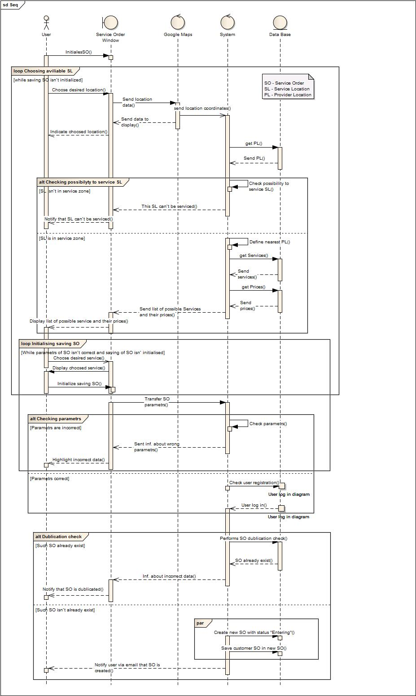

Figure 38 – Sequence diagram Service Order

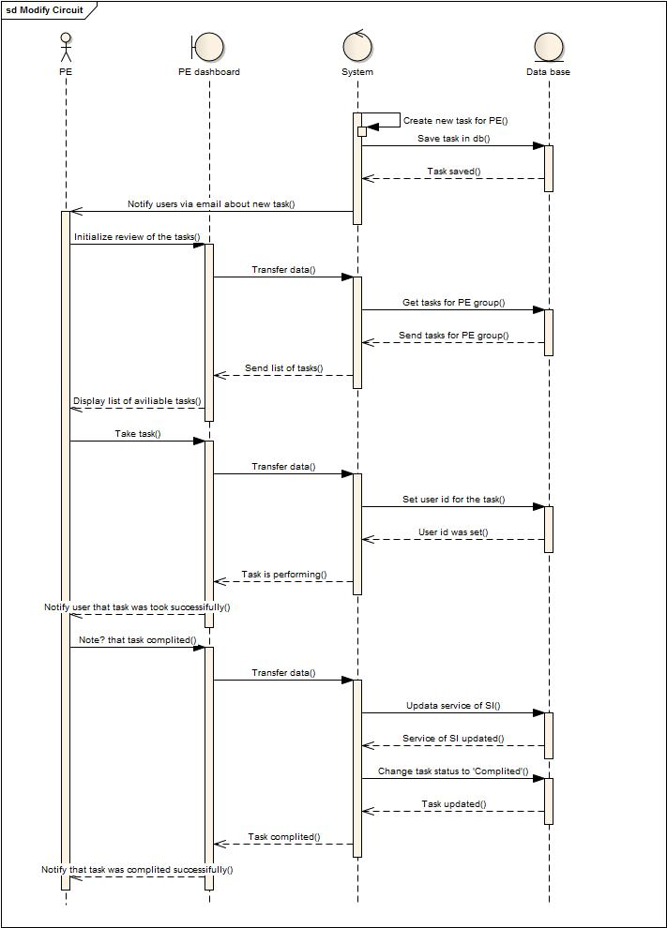

Figure 39 – Sequence diagram modify Circuit

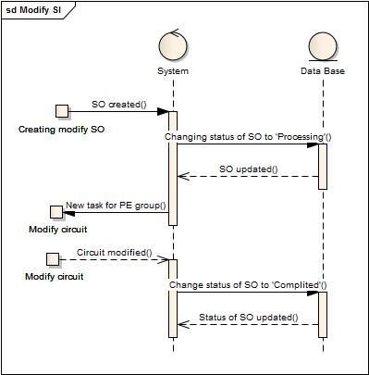

Figure 40 – Sequence diagram modify SI

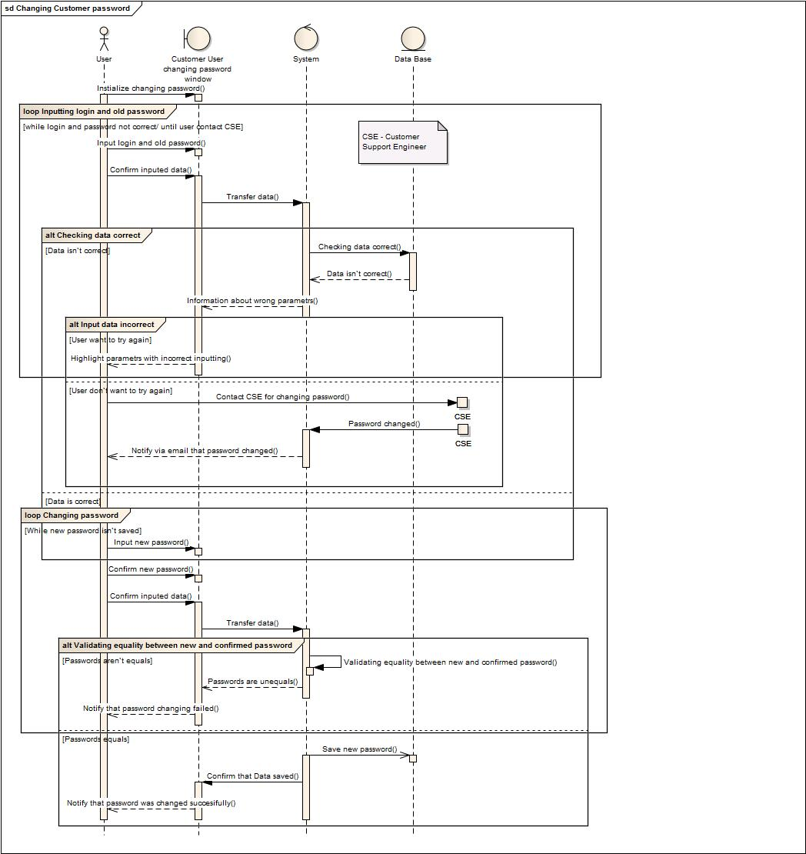

Figure 41 – Sequence diagram changing customer password

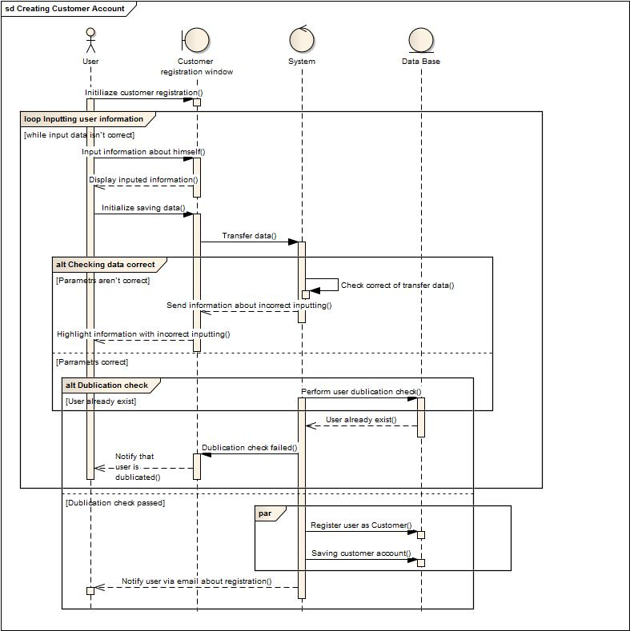

Figure 42 – Sequence diagram create customer account

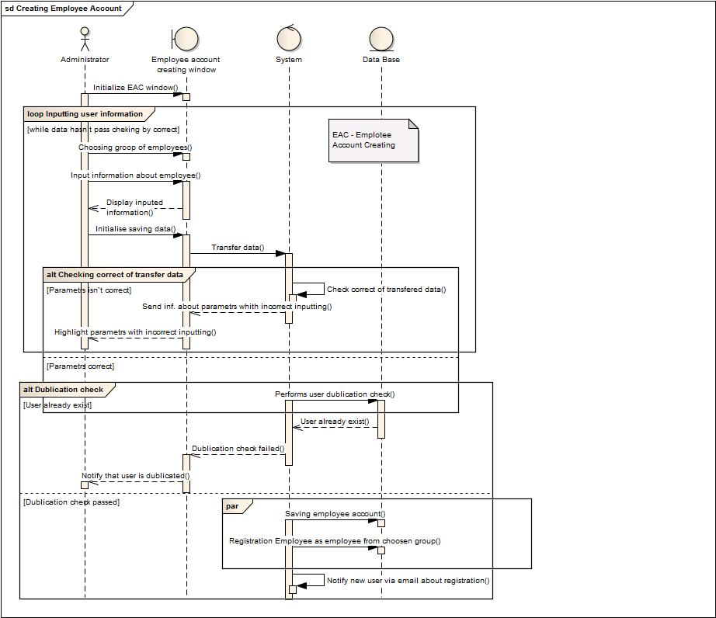

Figure 43 – Sequence diagram create employee account

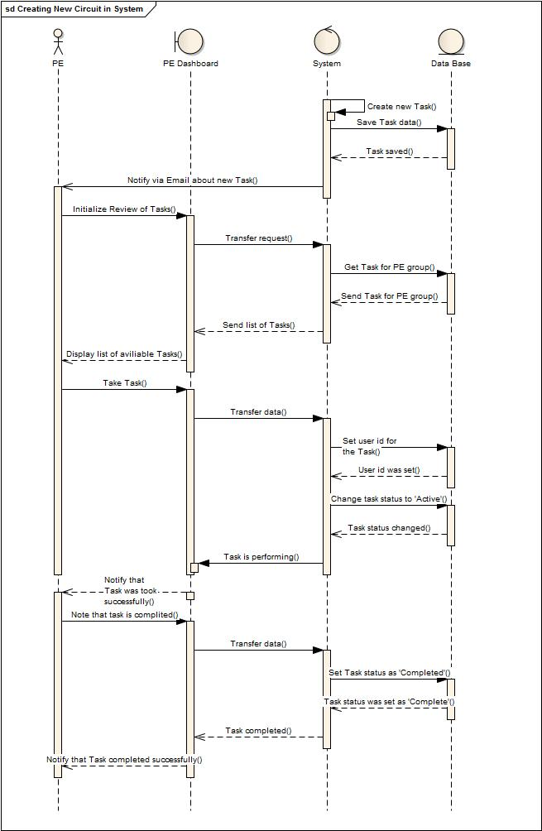

Figure 44 – Sequence diagram create new Circuit in system

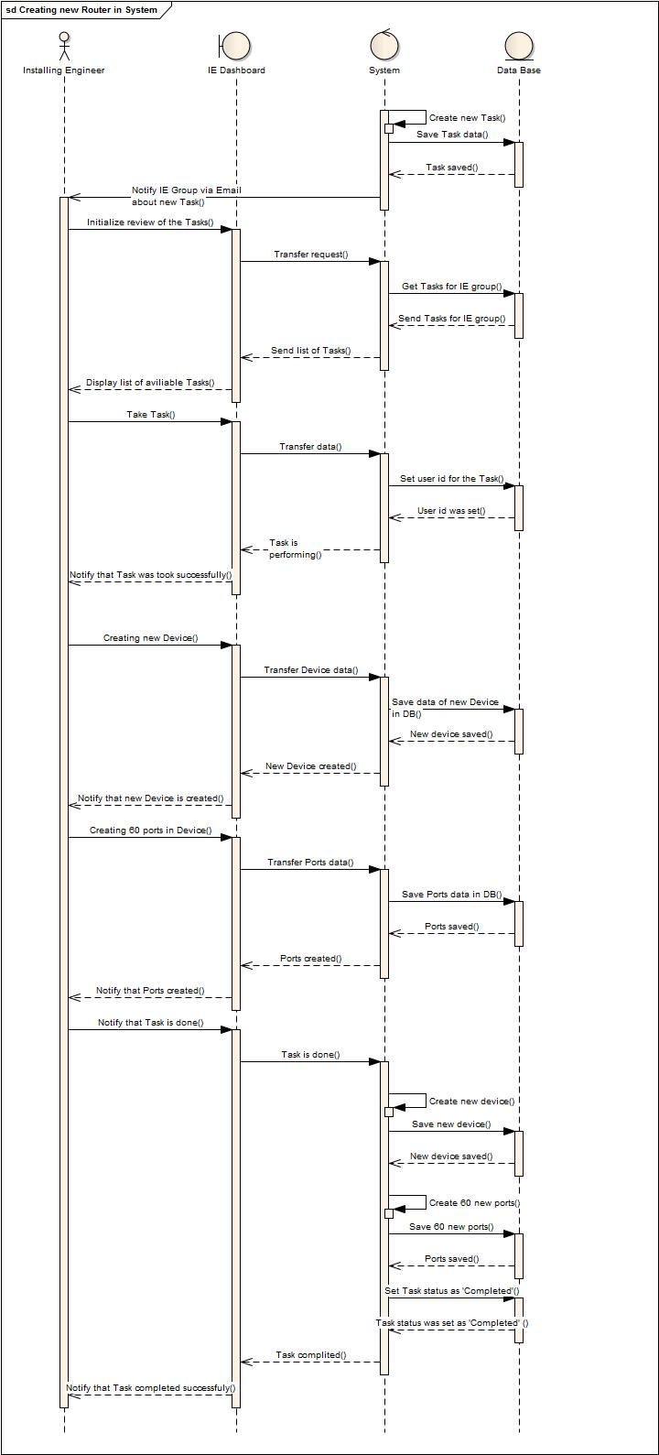

Figure 45 – Sequence diagram create new router in system

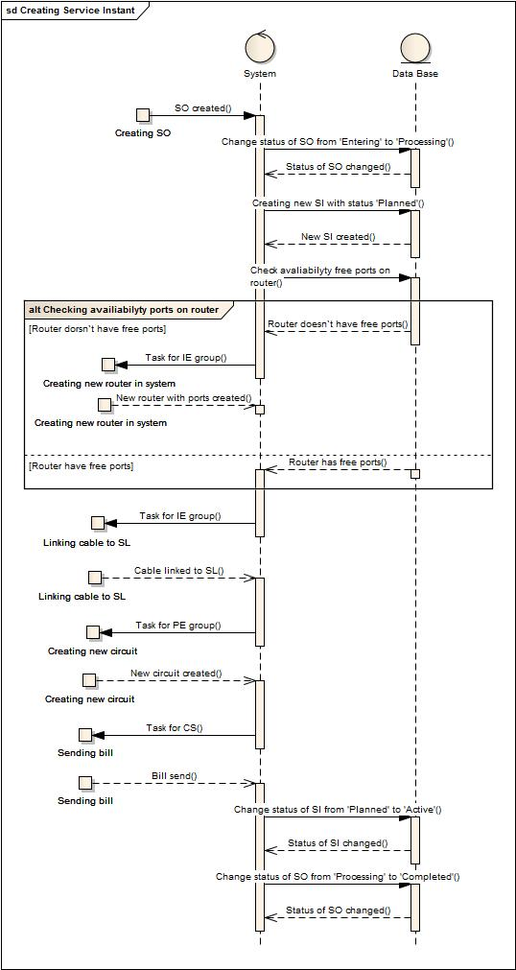

Figure 46 – Sequence diagram create Service Instance

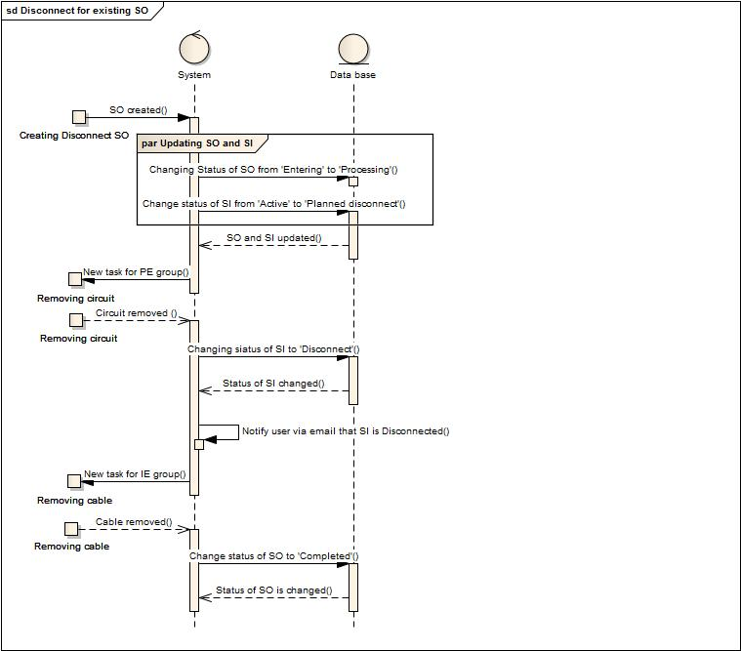

Figure 47 – Sequence diagram disconnect for existinf SI

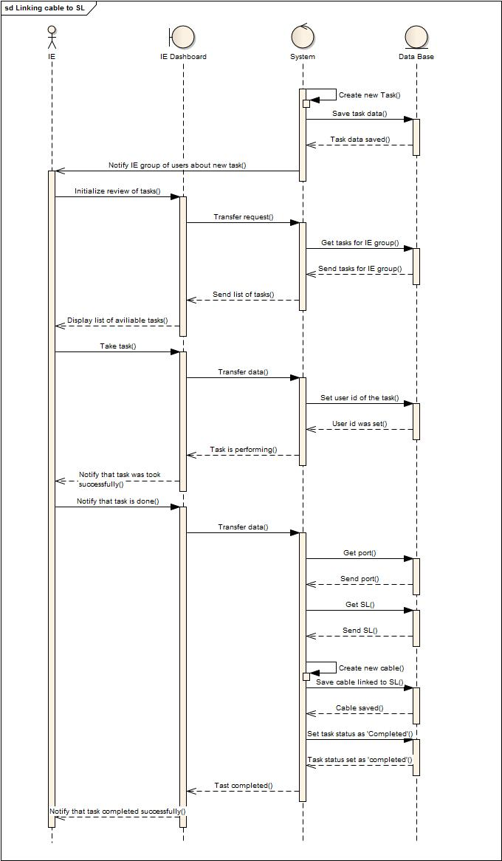

Figure 48 – Sequence diagram linking cable to SL

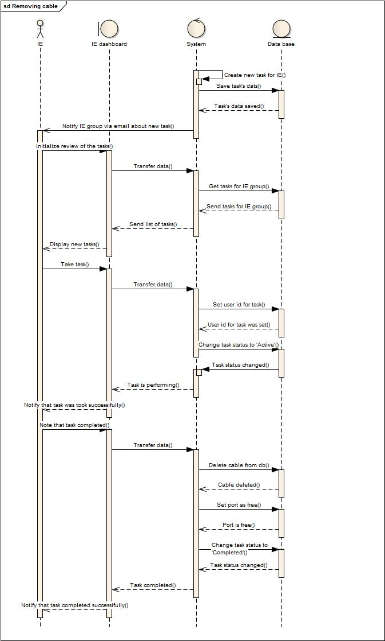

Figure 49 – Sequence diagram removing cable

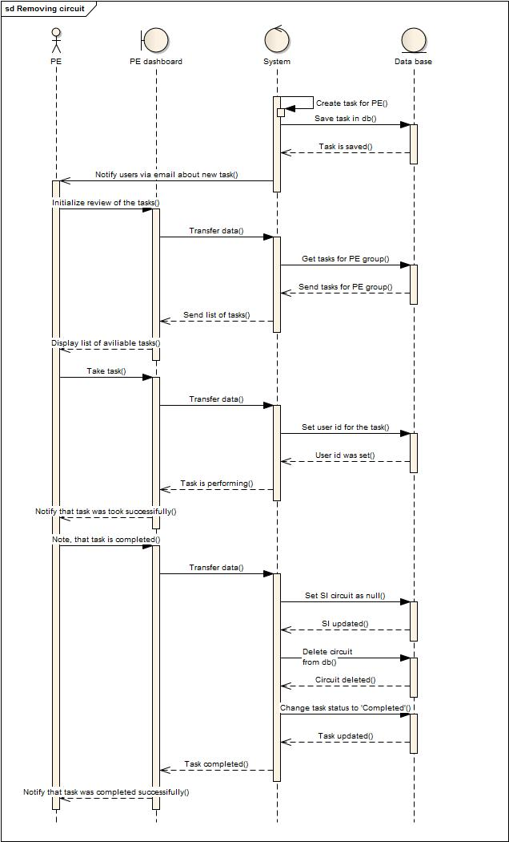

Figure 50 – Sequence diagram removing circuit

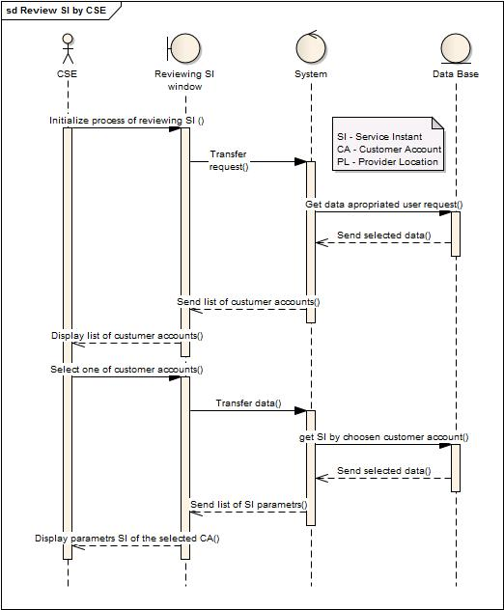

Figure 51 – Sequence diagram review SI by CSE

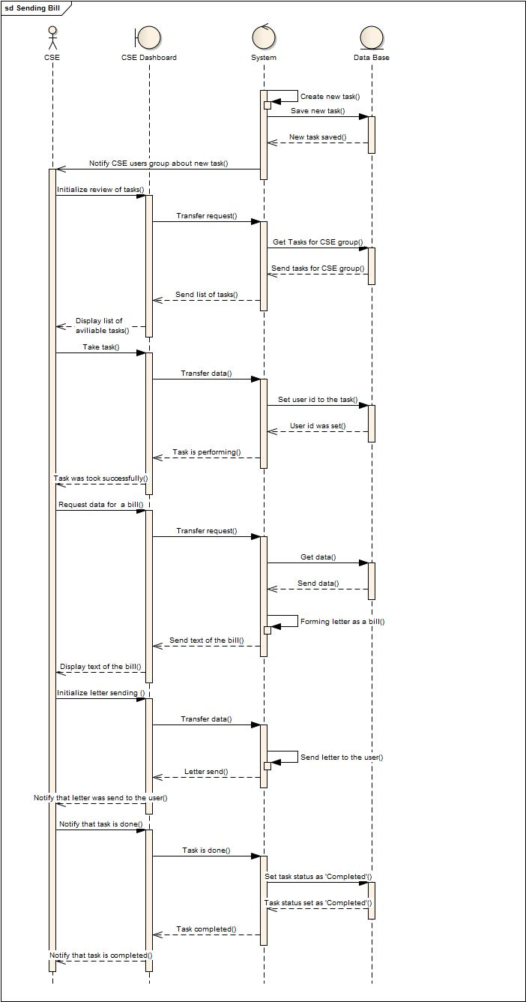

Figure 52 – Sequence diagram sending bill

## 3.5 Data managment

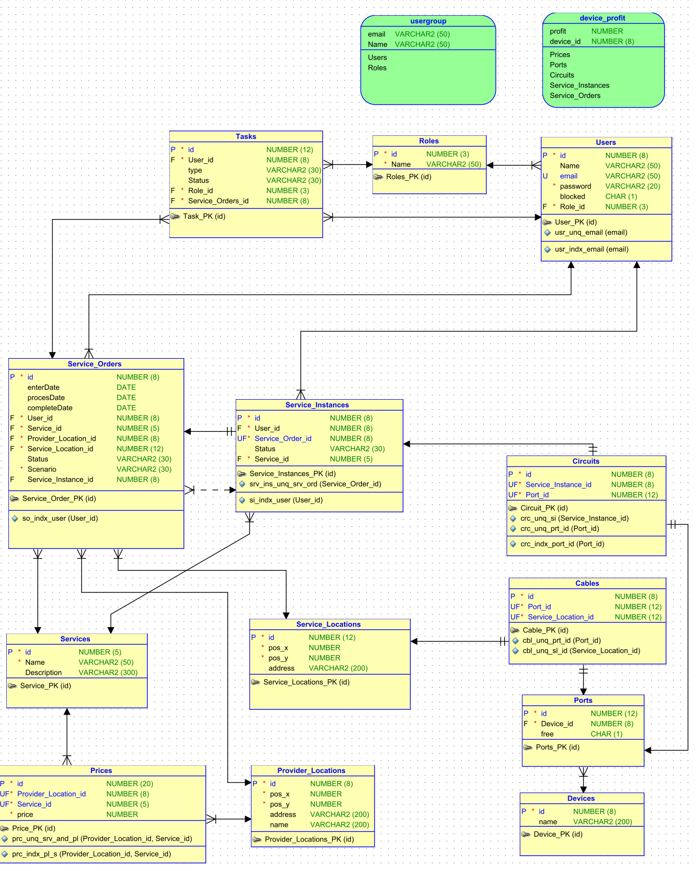

Figure 53 – ER-diagram

## 3.6. Security Architecture

The system allows to adjust the rights and roles to the user. Depending on the role, the system provides a different user interface and different rights.

Any user from internet can register in system as Customer User. Only Administrator can create employee accounts such as Customer Support Engineer, Provisioning Engineer, Installation Engineer. Only provider employee can perform administrative task.

Security matrix:

|  |  |  |  |  |  |
| --- | --- | --- | --- | --- | --- |
| Roles  Rights | Administrator | Customer Support Engineer | Provisioning Engineer | Installation Engineer | Customer User |
| Can create employee accounts | Yes | No | No | No | No |
| Can register in system himself | No | No | No | No | Yes |
| Can register customer user’s accounts | Yes | Yes | No | No | No |
| Can block other accounts | Yes | No | No | No | No |
| Can select services based on SL | No | Yes | No | No | Yes |
| Can review own SI | No | No | No | No | Yes |
| Can disconnect own SI | No | No | No | No | Yes |
| Can create new SO for himself | No | No | No | No | Yes |
| Can create new SO for customer users | No | Yes | No | No | No |
| Can creatie Devices, Ports and Cables in the system | No | No | No | Yes | No |
| Can create the circuit and refer the assigned port to SI | No | No | Yes | No | No |
| Can modify SI | No | No | Yes | No | Yes |
| Can generate RI reports | No | No | No | Yes | No |
| Can generate SI reports | No | Yes | No | No | No |
| Can generate CIA reports | No | No | Yes | No | No |
| Can change own password | Yes | Yes | Yes | Yes | Yes |
| Can change customer user’s password | Yes | No | No | No | No |
| Can review new task for CSE group | No | Yes | No | No | No |
| Can review new task for PE group | No | No | Yes | No | No |
| Can review new task for IE group | No | No | No | Yes | No |
| Can review list of customer user | Yes | Yes | No | No | No |
| Can review list of all user | Yes | No | No | No | No |

Security for Internet provider “Wind” integrated with existing security mechanism Java Authentication and Authorization Service and GlassFish Security.

# Reporting

The system provide a possibility to generate and to export reports to Excel, CSV format.

The system can generate:

1. RI reports:   
   - Routers utilization and capacity %  
   - Most profitable router  
   Reports are available to restricted user groups.
2. SI reports  
   - New orders per period  
   - Profitability by month  
   - Disconnect orders per period
3. CIA report  
   - Impact Propagation Tree

# 5 Resource Inventory

Resource Inventory includes resource topology, configuration, status, connectivity, and other information about it in a centralized store. Resource Inventory includes Physical and Logical Inventory, that provides modeling and management capabilities. The system can store information about devices, connected cables, installed ports, circiouts and their location. It is possible to add new devices.

# 6 Test Strategy

1. System description:

- Database Oracle XE;

- Application server Oracle Glassfish 4.0;

- Production server Amazon AWS.

2. Strategy description

Testing process includes 3 rounds. WIND.TC.SEC.004 test-case based on “white box” strategy for mandatory requirements control in system. Rest test-cases & test-sequences based on “black box” strategy. Some test-cases performed by one users group, but control of their result performs by other group.

3. Rounds of testing:

- Test-cases for security and access control testing execution;

- Test-cases for interoperability testing execution;

- Test-sequences for functional testing execution.

4. Start of testing criteria:

- Production server created;

- All mandatory functional requirements are completed;

- Software architecture and design documentation completed.

5. End of testing criteria:

- All test-cases and test-sequences are executed;

- System has less than 2 non-blocker and non-critical errors in test-cases based on optional requirements;

- System has no blocker and critical errors.

# 7 Product Testing

| **Action** | **Round 1. May 8-9, 2014** | **Round 2. May 10, 2014** | **Round 3. May 11, 2014** |
| --- | --- | --- | --- |
| WIND.TC.026. Non-functional requirements – Positive Scenario 1 | Completed | - | - |
| WIND.TC.023. SQL-injection – Positive Scenario 1 | Completed | Completed | Completed |
| WIND.TC.024. Viewing dashboards without right access – Positive Scenario 1 | Completed | - | Completed |
| WIND.TC.025. Viewing reports without right access – Positive Scenario 1 | Completed | - | Completed |
| **WIND.TS.001. “New user's day” test-sequence** | 89% Completed | Completed | Completed |
| WIND.TC.027. Map Integration – Positive Scenario 1 | Completed | Completed | Completed |
| WIND.TC.009. Creating Service Order – Negative Scenario 1 | Completed | Completed | Completed |
| WIND.TC.009. Creating Service Order – Negative Scenario 2 | Completed | Completed | Completed |
| WIND.TC.009. Creating Service Order – Positive Scenario 1 | Completed | Completed | Completed |
| WIND.TC.002. Creating Customer Accounts – Negative Scenario 1 | Completed | Completed | Completed |
| WIND.TC.002. Creating Customer Accounts – Negative Scenario 2 | 404 Error | Completed | Completed |
| WIND.TC.002. Creating Customer Accounts – Negative Scenario 3 | Completed | Completed | Completed |
| WIND.TC.002. Creating Customer Accounts – Positive Scenario 1 | Completed | Completed | Completed |
| WIND.TC.017. E-mail Notification – Positive Scenario 1 | Completed | Completed | Completed |
| **WIND.TS.002. “Customer user's day” test-sequence** | Completed | Completed | Completed |
| WIND.TC.022. User Logs In – Positive Scenario 1 | Completed | Completed | Completed |
| WIND.TC.004. Changing Customer Password – Negative Scenario 1 | Completed | Completed | Completed |
| WIND.TC.004. Changing Customer Password – Negative Scenario 2 | Completed | Completed | Completed |
| WIND.TC.004. Changing Customer Password – Positive Scenario 1 | Completed | Completed | Completed |
| WIND.TC.009. Creating Service Order – Negative Scenario 1 | Completed | Completed | Completed |
| WIND.TC.009. Creating Service Order – Negative Scenario 2 | Completed | Completed | Completed |
| WIND.TC.009. Creating Service Order – Positive Scenario 1 | Completed | Completed | Completed |
| WIND.TC.017. E-mail Notification – Positive Scenario 1 | Completed | Completed | Completed |
| WIND.TC.015. Modifying Parameters for Service Instance – Positive Scenario 1 | Completed | Completed | Completed |
| WIND.TC.016. Disconnect for Existing Service Instance – Positive Scenario 1 | Completed | Completed | Completed |
| **WIND.TS.003. “Installation Engineer's day” test-sequence** | Completed | Completed | Completed |
| WIND.TC.022. User Logs In – Positive Scenario 1 | Completed | Completed | Completed |
| WIND.TC.007. Installing New Router in System – Positive Scenario 1 | Completed | Completed | Completed |
| WIND.TC.007. Installing New Router in System – Positive Scenario 2 | Completed | Completed | Completed |
| WIND.TC.018-020. Creating Reports | Completed | Completed | Completed |
| WIND.TC.021. Exporting Reports – Positive Scenario 4 | Completed | Completed | Completed |
| WIND.TC.013. Bill Sending – Positive Scenario 1 | Completed | Completed | Completed |
| **WIND.TS.004. “Provisioning Engineer's day” test-sequence** | Completed | Completed | Completed |
| WIND.TC.022. User Logs In – Positive Scenario 1 | Completed | Completed | Completed |
| WIND.TC.011. Creating New Circuit in System – Positive Scenario 1 | Completed | Completed | Completed |
| WIND.TC.012. Removing the Citcuit in System – Positive Scenario 1 | Completed | Completed | Completed |
| WIND.TC.001. Modifying Parameters for Service Instance – Positive Scenario 1 | Completed | Completed | Completed |
| WIND.TC.018-020. Creating Reports | Completed | Completed | Completed |
| WIND.TC.021. Exporting Reports – Positive Scenario 3 | Completed | Completed | Completed |
| WIND.TC.013. Bill Sending – Positive Scenario 1 | Completed | Completed | Completed |
| **WIND.TS.005. “Customer Support Engineer's day” test-sequence** | 90 % Completed | Completed | Completed |
| WIND.TC.022. User Logs In – Positive Scenario 1 | Completed | Completed | Completed |
| WIND.TC.008. Creating Customer Account by Customer Support Engineer – Negative Scenario 1 | Completed | Completed | Completed |
| WIND.TC.008. Creating Customer Account by Customer Support Engineer – Negative Scenario 2 | 404 Error | Completed | Completed |
| WIND.TC.008. Creating Customer Account by Customer Support Engineer – Negative Scenario 3 | Completed | Completed | Completed |
| WIND.TC.008. Creating Customer Account by Customer Support Engineer – Positive Scenario 1 | Completed | Completed | Completed |
| WIND.TC.005. Review Service Instance – Positive Scenario 1 | Completed | Completed | Completed |
| WIND.TC.006. Review Service Order – Positive Scenario 1 | Completed | Completed | Completed |
| WIND.TC.018-020. Creating Reports | Completed | Completed | Completed |
| WIND.TC.021. Exporting Reports – Positive Scenario 2 | Completed | Completed | Completed |
| WIND.TC.013. Bill Sending – Positive Scenario 1 | Completed | Completed | Completed |
| **WIND.TS.005. “Customer Support Engineer's day” test-sequence** | Completed | Completed | Completed |
| WIND.TC.001. Creating Employee Account – Negative Scenario 1 | Completed | Completed | Completed |
| WIND.TC.001. Creating Employee Account – Negative Scenario 2 | Completed | Completed | Completed |
| WIND.TC.001. Creating Employee Account – Positive Scenario 1 | Completed | Completed | Completed |
| WIND.TC.001. Creating Employee Account – Positive Scenario 2 | Completed | Completed | Completed |
| WIND.TC.001. Creating Employee Account – Positive Scenario 3 | Completed | Completed | Completed |
| WIND.TC.003. Blocking Accounts – Positive Scenario 1 | Completed | Completed | Completed |
| WIND.TC.003. Blocking Accounts – Positive Scenario 2 | Completed | Completed | Completed |
| WIND.TC.003. Blocking Accounts – Positive Scenario 3 | Completed | Completed | Completed |
| WIND.TC.003. Blocking Accounts – Positive Scenario 4 | Completed | Completed | Completed |
| WIND.TC.003. Blocking Accounts – Negative Scenario 1 | Completed | Completed | Completed |
| WIND.TC.003. Blocking Accounts – Negative Scenario 2 | Completed | Completed | Completed |
| WIND.TC.003. Blocking Accounts – Negative Scenario 3 | Completed | Completed | Completed |
| WIND.TC.003. Blocking Accounts – Negative Scenario 4 | Completed | Completed | Completed |
| WIND.TC.018-020. Creating Reports | Completed | Completed | Completed |
| WIND.TC.021. Exporting Reports – Positive Scenario 1 | Completed | Completed | Completed |
| Overal | 99 % Completed, 2 bugs | Completed, 0 bugs | Completed, 0 bugs |